Name Date

2.6B HW

2.6

The two figures are similar. Find the ratio (small to large) of the perimeters and of the areas.

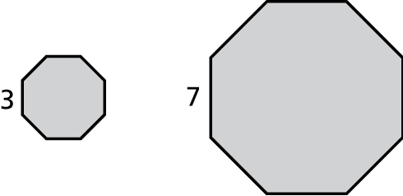 1. 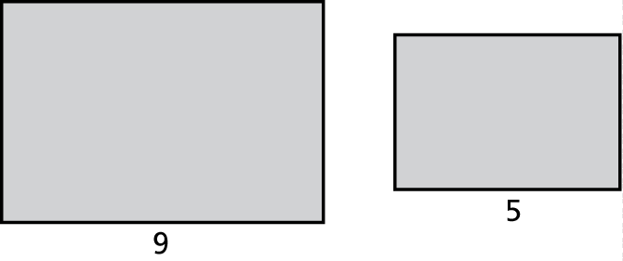 2.

4. The ratio of the corresponding side lengths of two similar rectangular tables is 4:5.

a. What is the ratio of the perimeters?

b. What is the ratio of the areas?

c. The perimeter of the larger table is 44 feet. What is the perimeter of the smaller table?

5. The figures are similar. The ratio of the perimeters is 5:9. Find *x*.

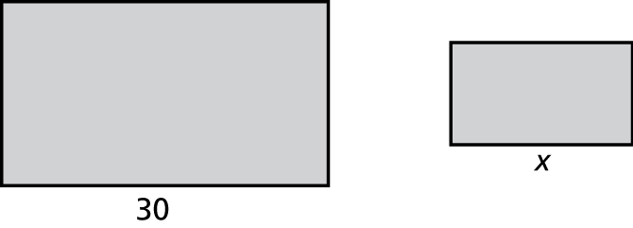

**BACK 🡪**

6. The ratio of the area of Triangle *A* to Triangle *B* is 16:49. Triangle *A* is similar to Triangle *B*.

a. Which triangle is larger, *A* or *B*?

b. A side length of Triangle *B* is 3.5 inches. What is the corresponding side length of Triangle *A*?

c. What is the ratio of the perimeter of Triangle *A* to the perimeter of Triangle *B*?

d. (EXTRA CREDIT) The side lengths of Triangle *A* are increased by 40%. The side lengths of Triangle *B* do not change. What is the new ratio of the area of Triangle *A* to Triangle *B*?

