Name: ______________________ Table #:___________ Period: ______ Date: _______
2.7A NOTES – Dilations
Objective: Dilate figures in the coordinate plane; write notation rule for dilation. CC.SS.8.G.3 and G.4
- To dilate an object means to ___________________ the size of an object or to ___________________________ the size of an object.
- The ___________________ ____________________ will determine how much larger or smaller the object will become.
- A scale factor ___________________ _______________ 1 means the object will increase in size.
- A scale factor ___________________ ______________ 1 means the object will decrease in size.
- A dilated image will always be _______________________ to its original.

Transformations Notation
- A transformation transforms, or maps, the original point to another point. Transformation uses a combination of operation ($+, -, ÷,$x)
- notation: ↦ “maps to” (it is a rule that you have to apply)
EXAMPLE: (x, y) ↦ (x+3, y) --> (5, 12) ↦ (5+3, 12) --> (5, 12) ↦ (8, 12)

1.  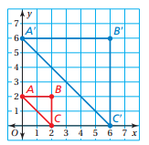 | 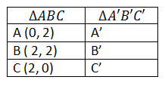 | Enlargement or reduction?  Scale Factor:  Notation Rule: (x, y)
2.  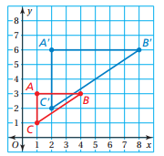 | 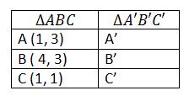 | Enlargement or reduction?  Scale Factor:  Notation Rule: (x, y)
3.  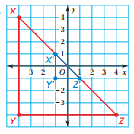 | 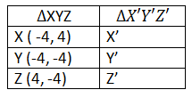 | Enlargement or reduction?  Scale Factor:  Notation Rule: (x, y)
4.  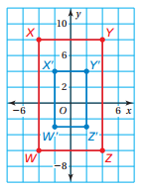 | 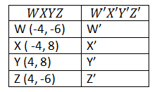 | Enlargement or reduction?  Scale Factor:  Notation Rule: (x, y)
BACK
Extra Example 2 (textbook)  The vertices of a triangle are D(1,4), E(1,1) and F(3,1). Draw the triangle and its image after a dilation with a scale factor of 2.  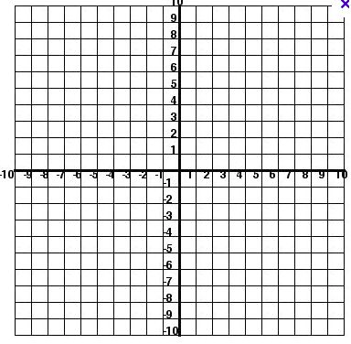  Type of dilation:  Notation rule: (x, y) | Extra Example 3 (textbook)  The vertices of a rectangle are J(-4,2), K(4,2), L(4,-2), and M(-4, -2). Draw the rectangle and its image after a dilation with a scale factor of 0.5.  Type of dilation:  Rotation rule: (x, y)

Watch the video if you need help: https://www.youtube.com/watch?v=DhZ_Z69zaeE

The scale factor “k” is the ratio of the length of any side in the image to the length of its corresponding side in the pre-image. It describes how much the figure is enlarged or reduced. $k=\frac{Image}{Pre-image}$

5.  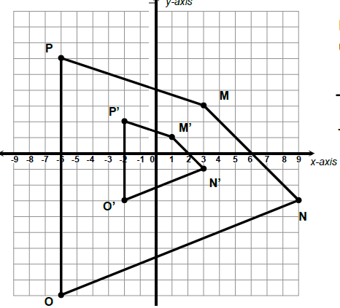  Describe the dilation (enlarge or reduce):  Scale factor:  Notation Rule: | 6.  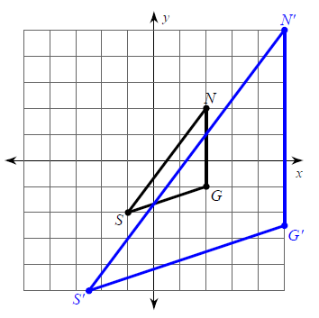  Describe the dilation (enlarge or reduce):  Scale factor:  Notation Rule:
https://www.youtube.com/watch?v=gAmo3FcaovM (D.M. Clip)
Watch the video for notes: https://www.youtube.com/watch?v=mWrvZdxQ0_A

