Name: ______________________ Table #:___________ Period: ______ Date: _______
2.7B Dilations_Classwork
REVIEW
Use Point A(2,3)
- (x, y) (2x, 2y) _____________________________________ Image coordinate: _______________

- (x, y) ($\frac{1}{4}$x, $\frac{1}{4}$y) ______________________________________ Image coordinate: _______________

- (x, y) (2.5x, 2.5y) ___________________________________ Image coordinate: _______________

- (x, y) (0.5x, 0.5Y) ___________________________________ Image coordinate: _______________

Watch the video if you need help: https://www.youtube.com/watch?v=EYKsegMY8M8
1.  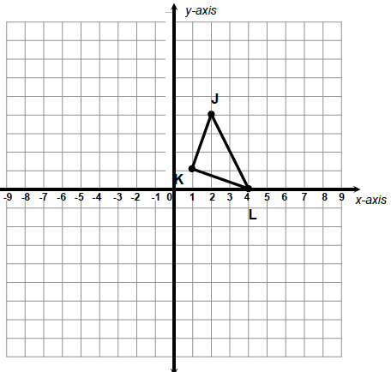  Graph the dilated image of triangle JKL using a scale factor of 2 and (0, 0) as the center of dilation.  Notation Rule: _________________________________  J: K: L:  J’: K’: L’: | 2.  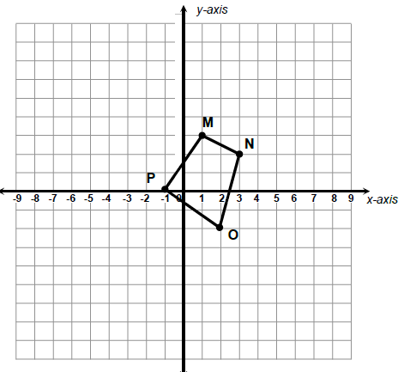  Graph the dilated image of quadrilateral MNOP using scale factor of 3 and the origin as the center of dilation.  Notation Rule: _________________________________  M: N: O: P:  M’: N’: O’: P’:
3.  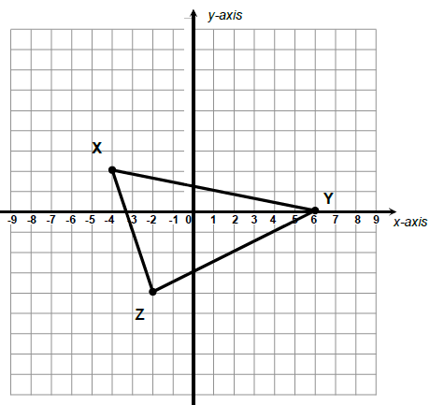  Graph the dilated image of triangle XYZ using a scale factor of 1.5 and (0, 0) as the center of dilation  Notation Rule: _________________________________  X: Y: Z:  X’: Y’: Z’: | 4.  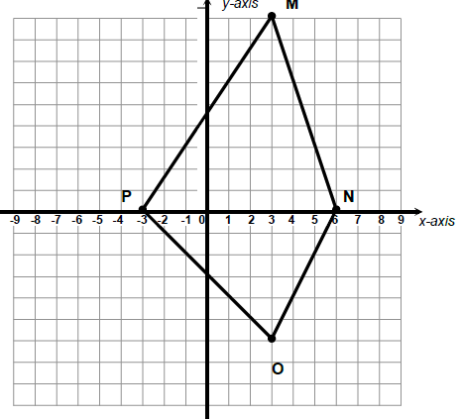  Graph the dilated image of quadrilateral MNOP using a scale factor of 1/3 and (0, 0) as the center of dilation  Notation Rule: _________________________________  M: N: O: P:  M’: N’: O’: P’:

- Triangle ABC is dilated by a scale factor of 3  - Draw $∆ABC$ and its image after a dilation with scale factor of 3.  A (1, 3) B (2, 3) C (2, 1)  - Identify the coordinate notation.  (x,y) ( )  - Identify the type of dilation.  - Identify the coordinates of the image.  A’ ( ) B’ ( ) C’ ( ) | 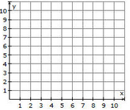
- Rectangle WXYZ is dilated by a scale factor of ¼.  - Draw WXYZ and its image after a dilation with scale factor of ¼. (HINT: ¼ = 0.25)  W (-4, -6) X (-4, 8) Y (4, 8) Z (4, -6)  - Identify the coordinate notation.  (x,y) ( )  - Identify the type of dilation.  - Identify the coordinates of the image.  W’ ( ) X’ ( )  Y’ ( ) Z’ ( ) | 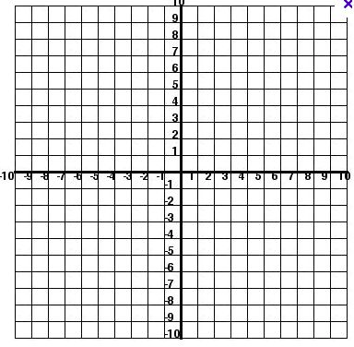
- Figure JKLM is dilated by a factor of $\frac{1}{3}$. If point K of figure JKLM is (6, 9), what are the coordinates of K’
after the scale factor of $\frac{1}{3}$ is applied?

WARM-UP
The ratio of the corresponding linear measures of two similar cans of vegetables is 2 to 3. The smaller can has a surface area of 300 square centimeters. What is the surface area of the bigger can?

Objective: Dilate figures in the coordinate plane; write notation rule for dilation. CC.SS.8.G.3 and G.4
worksheet 2.7B HW

