Name: ____________________________ Table #: ______ Period: ______ Date: ____
2.7B HW
Write a rule to describe each transformation.
1.  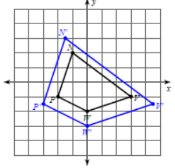  Notation Rule:  (x,y) | 2.  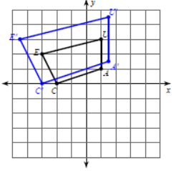  Notation Rule:  (x,y) | 3.  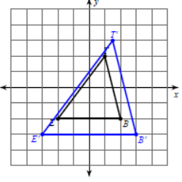  Notation Rule:  (x,y) | 4.  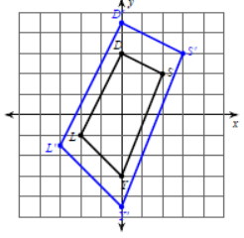  Notation Rule:  (x,y)

Graph the image of the figure using transformation given.
5.  Dilation of 0.5  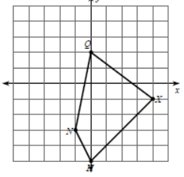  Notation Rule:  (x, y)  Type of Dilation: | 6.  Dilation of $\frac{3}{5}$ A(-5, 5) B(-5, 10) C(10, 0)  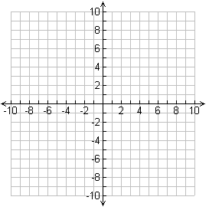  Notation Rule:  (x, y)  Type of Dilation:

BACK

Determine whether the dilation from Figure A to Figure B is a reduction or an enlargement. Then, find the values of the variables.
7.  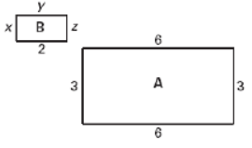 | 8.  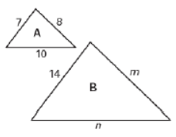
9.  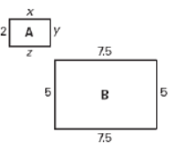 | 10.  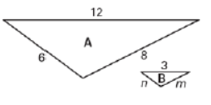

11.
The screen on your old television is 20 inches wide and 15 inches high. The screen on your new widescreen television is 16 inches wide and 9 inches high. Is the screen on your new TN a dilation of the screen on your old TV? Explain.

