Chapter 2 Project - CREATING MULTIPLE TRANSFORMATIONS (8.G.4)
Objective: Create examples of multiple transformations for other students to figure out. CCSS: 8.G.4

You will be creating a figure and then transforming it two times by either translation, reflection, or rotation about the origin. You cannot use the same type of transformations twice. You will then present your figure and the final image to another student. This student should determine the steps involved to go from the original figure to the final image.

STEPS:
- Create a figure (parallelogram, trapezoid, quadrilateral (not a square or rectangle), or a pentagon)
- Name it (Example: Parallelogram WXYZ). Record the coordinates of the pre-image.
- Transform it two times (use Translation, Reflection, and/or Rotation about the origin). Record the coordinate images and the coordinate notation for all 3 figures (the original figure, the second image and the final image.) Label the vertices of all 3 images.
- Complete the table and graph on the back (see example of table for assistance)
- Go to www.desmos.com/calculator
Use the example below (EXAMPLE FROM DESMOS.COM/CALCULATOR) as a model for your project.
- Type in the pre-image and final image.
- Screen shot or use a snipping tool and paste in a Google Doc.
- Title this document Chapter 2 Project with your name. Include your name, date and period on the top of the document.
- Write the directions so another student can follow. Do not include the steps.
EXAMPLE: Triangle ABC has been transformed two times. Determine the two steps to get from the pre-image to the final image.

EXAMPLE OF TABLE
PRE-IMAGE  COORDINATES | TYPE OF TRANSFORMATION | RULE NOTATION  (COORDINATE NOTATION) | IMAGE  COORDINATES
A (1, 3)  B (4, 3)  C (4, 5) | Reflect over the  x-axis | (x, y) (x, -y) | A’ (1, -3)  B’ (4, -3)  C’ (4, -5)
A’ (1, -3)  B’ (4, -3)  C’ (4, -5) | Translate 3 units left | (x, y) (x - 3, y) | A’’ (-2, -3)  B” (1, -3)  C” (1, -5)

EXAMPLE FROM DESMOS.COM/CALCULATOR
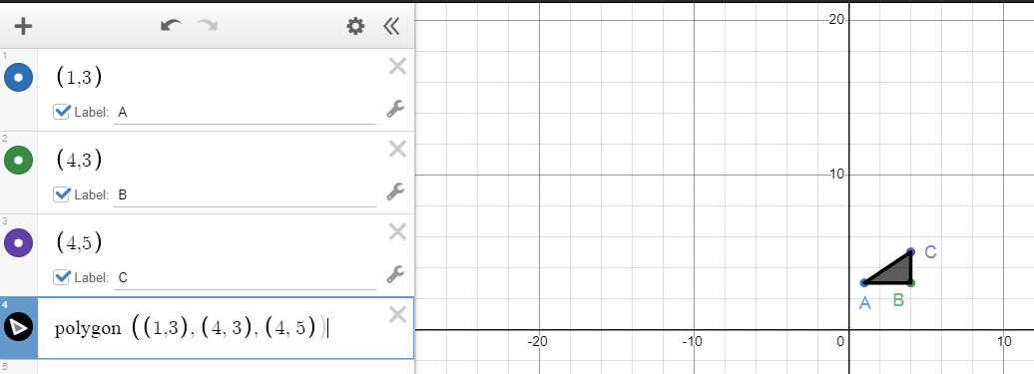
NAME: __________________________________ Per. ___ CH. 2 PROJECT Multiple Transformations

FIGURE: ______________________________

PRE-IMAGE  COORDINATES | TYPE OF TRANSFORMATION | RULE NOTATION  (COORDINATE NOTATION) | IMAGE  COORDINATES
 |  | (x, y)
 |  | (x, y)

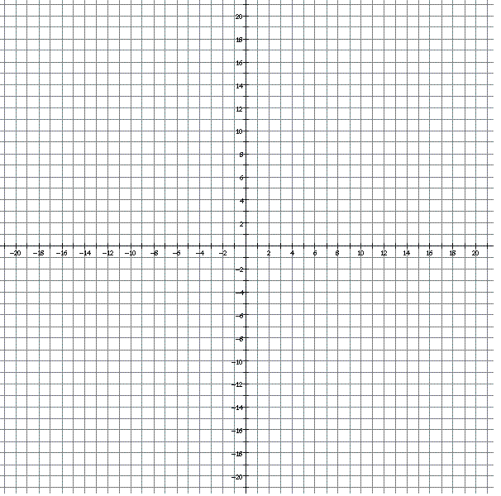
Complete the worksheet: _______/15 pts
Complete the final product in Google doc and share it to tcao@sandi.net:
_______/10 pts
++++++++++++++++++
TOTAL: _____/25 pts
How to graph shapes in desmo:
https://www.youtube.com/watch?v=eOgYKBUcJ6Q
https://www.youtube.com/watch?v=x3rEQ-YiTrA

NAME: ___________________________PERIOD: _____________________________
CHAPTER 2 MULTIPLE TRANSFORMATION PROJECT
FINAL PRODUCT EXAMPLE:
