Name: ________________________ Table #: ______ Period: _______ Date: _______
CH 7 SBAC Practice 3 (Pythagorean Theorem)_Classwork
HW: Ch. 7 Review p. 325 #2, 4 – 12, 15 – 17, 19, 24 – 27 (do in BIM)

Warm Up: Evaluate the expression (7.1 & 7.2)
- $12+8\sqrt{16}$ | - $\frac{1}{2}+ \sqrt{\frac{72}{2}}$ | - ${\left(\sqrt[3]{-125}\right)}^{3}+75$

Use Pythagorean Theorem to find the missing side. (7.3)
1.  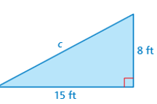 | 2.  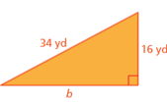

Find the missing length of the figures
EXAMPLE
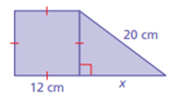

3.  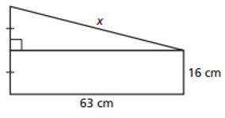 | 4.  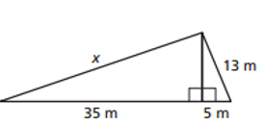
Use Pythagorean Theorem to solve the word problems. (7.5)
6.  An isosceles triangle has congruent sides of 15 cm.  The base is 8 cm. What is the area of the triangle?  (Round your answer to the nearest tenth.) | 7.  A softball diamond is a square that is 60’ on each side. If a player throws the ball from 1st base to 3rd base, how far will the ball travel? (Round your answer to the nearest tenth.)

Use the distance formula to find the distance between the 2 points: $d= \sqrt{{\left(y_{2}-y_{1}\right)}^{2}+{\left(x_{2}-x_{1}\right)}^{2}}$

8. (6, 8) and (5, -2) | 9. (2, 10) and (3, -8)

Without using a calculator, estimate the following square roots to
a) the nearest integer and b) the nearest tenth

EXAMPLE:  $\sqrt{60}$  a) 60 is between the perfect squares 49 & 64. It is closer to 64. Since $\sqrt{64}=8$, $\sqrt{60} ≈8$  b) Guess and Check to estimate to the nearest tenth  7.6² = 57.76 7.7² = 59.24 7.8² = 60.84  SO $\sqrt{60}$ $≈7.7$ | 5. $\sqrt{24}$

