Name: ________________________ Table #: ________ Period: _______ Date: ________

**3.0A Angles Review_Classwork**

*Objective: use facts about supplementary, complementary, vertical, and adjacent angles in a multi-step problem to write and solve simple equations for an unknown angles in a figure. CC.SS.7.G.5*

*Homework- R&P page 49 & 50 #1-10 ALL - CH 3 “FAIR GAME REVIEW”*

**Vertical Angles**: angles that are opposite each other when two lines cross. Vertical angles share a vertex and are **congruent**.

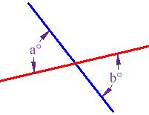



**Adjacent Angles**: Two angles that share a common side and have the same vertex.

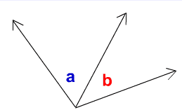

 and  are adjacent

**Complementary Angles:** The angle measures add up to 90o (two or more angles form a right angle).

**Supplementary Angles:** The angle measures add up to 180o (two or more angles form a straight angle).

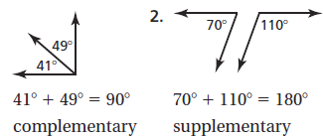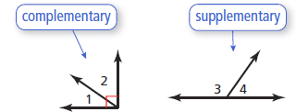

+++++++++++++++++++++++++++++++++++++++++++++++++++++++++++++++++++++++++++++++++++++++++

**Tell whether the angles are *vertical, complementary or supplementary*. Then find the value of x.**

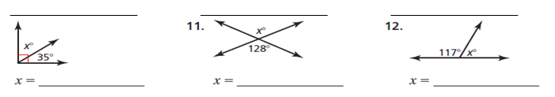

**3.**

**2.**

**1.**

READ EXAMPLES 1 & 2 P. 101. THEN DO “TRY IT YOURSELF #1-4

|  |
| --- |
| **Example 1: Tell whether the angles are adjancent or vertical. Then find the value of x.** |
| **Example 2: Tell whether the angles are complementary or supplementary. Then find the value of x.** |
| **PRACTICE PROBLEMS** |
| **Tell whether the angles are adjacent or vertical. Then find the value of x.** |
| **Tell whether the angles are complementary or supplementary. Then find the value of x.** |

Video: <https://www.youtube.com/watch?v=DGKwdHMiqCg> <https://www.youtube.com/watch?v=QjwbvNdUSTk>