Name Date

3.0A HW

Tell whether the angles are *adjacent* or *vertical*. Then find the value of *x*.

1. 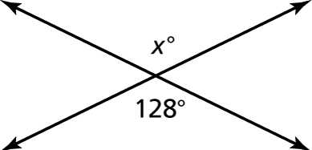 2. 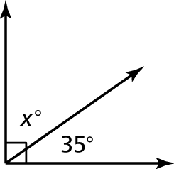

3. 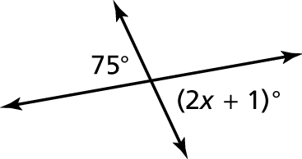 4. 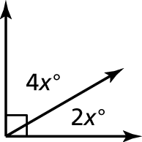

5. The tree is tilted Find the value of *x*.

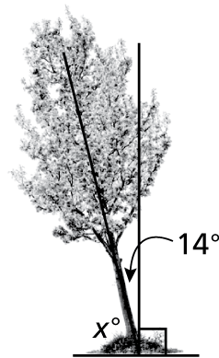

Name Date

Fair Game Review **(continued)**

Chapter

3

Tell whether the angles are *complementary* or *supplementary*. Then find the value of *x*.

6. 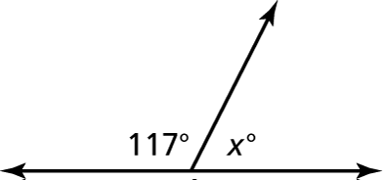 7. 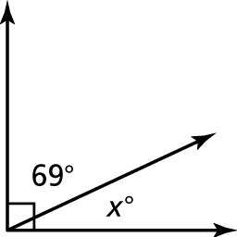

8. 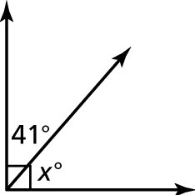 9. 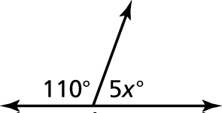

10. A tributary joins a river at an angle. Find the value of *x*.

