Name: _______________________ Table #: _______ Period: ____________ Date: ___________
3.0A NOTES – Intro to Angles
Watch the Youtube: https://www.youtube.com/watch?v=DGKwdHMiqCg
Parallel lines | Intersection lines
How to write angle  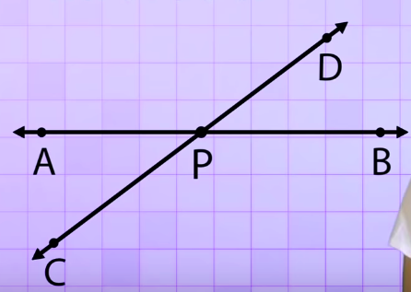 | Perpendicular Lines
Right Angle: | Acute Angle:
Obtuse Angle: | Straight Angle:
Complementary Angles:  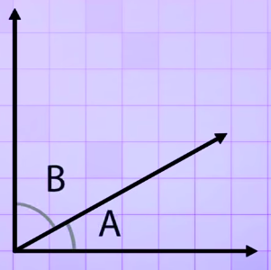 | Supplementary Angles:  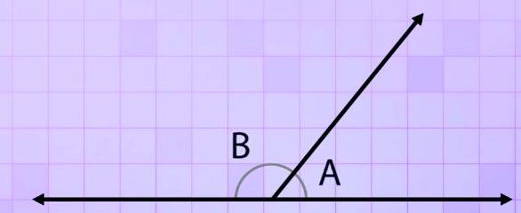

BACK
Watch the Youtube: https://www.youtube.com/watch?v=6RMN5Pf1fHU
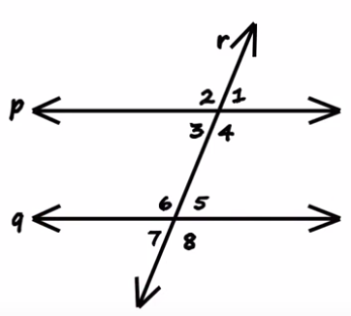

Corresponding Angles  $$∡1= ______$$  $$∡2= ______$$  $$∡3= ______$$  $$∡4= ______$$ | Alternating Interior Angles  $$∡3= ______$$  $$∡6= ______$$
Consecutive Interior Angles  $$∡3= ______$$  $$∡4= ______$$ | Vertical Angles  $$∡1= ______$$  $$∡2= ______$$  $$∡5= ______$$  $$∡6= ______$$

