Name: ____________________ Table #: ____ Period: _____ Date: _______
3.1-3.2 Review QUIZ
The “measure of $∠1$” is the same as “$m∠1.$”
- Use the figure to find the measures of $∠1$and $∠2$.  $$m∠1= _____$$  $$m∠2= _____$$ | - Use the figure to find measures of the numbered angles.  $$m∠1= _____$$  $$m∠2= _____$$  $$m∠3= _____$$  $$m∠4= _____$$
- Determine whether each statement is true or false and explain the reason.  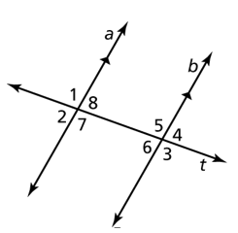  - If $m∠1=60°$, then the measure of  $m∠5=120°$. _______________ because  ______________________________________  - If $m∠6=37°$, then the measure of  $m∠2=37°$. _______________ because  ______________________________________ | - Describe the relationship between each pair of angles. (corresponding, alternate interior, alternate exterior, vertical, or no relationship)  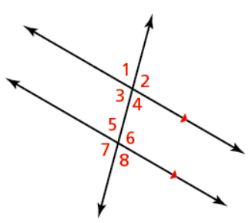  - $∠2=∠6$ ______________________________  - $∠4=∠1$ ______________________________  - $∠3=∠6$ ______________________________  - $∠2=∠5$ ______________________________  - $∠1=∠8$ ______________________________
- Find the value of x.  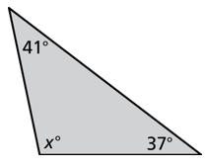  x = ____________ | - Find the value of x.  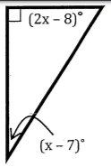  x = ____________
BACK
- Find the measure of the exterior angle.  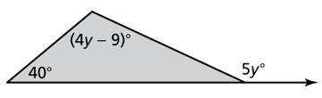  The measure of the exterior angle is ___________ | - Write an equation for the value of y in terms of x. Then solve the equation for x.  $$y°$$  $$29°$$  $$x°$$  y = ______________ x = ______________
- The figure shows a truss used in the construction of a building. The measure of $∠3$ is $25°$. Find the measure of $∠4$.  $$3$$  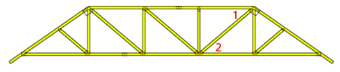  $$4$$  $$m∠4=__________$$ | - Find the angle x (in degrees) that the wheelchair ramp makes with the ground.  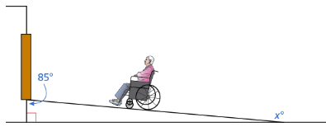  $$76°$$  x = ______________

