Name Date

**3.1 A Parallel Lines and Transversals_Classwork**

Use the figure to find the measures of the numbered angles.

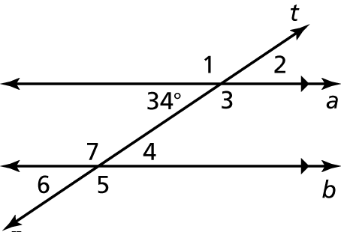 1. 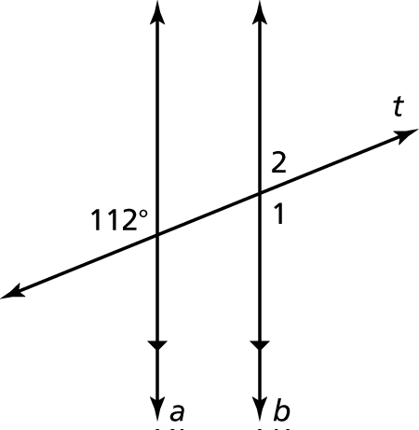 2.

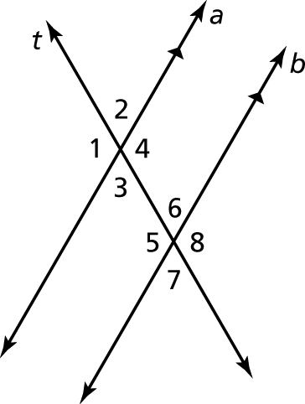Complete the statement. Explain your reasoning.

3. If the measure of  then the measure of 

4. If the measure of  then the measure of 

5. If the measure of  then the measure of 

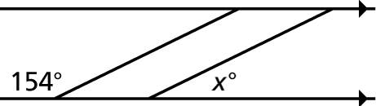 6. You paint a border around the top of the walls   
in your room. What angle does *x* need to be to   
repeat the pattern?

Video: <https://www.youtube.com/watch?v=5PcMbN46NMA>