Name: ______________________________ Table #:___________ Period: _____ Date: ______
3.1B NOTES – Parallel Lines And Transversal
Objective: Identify angles created when parallel lines are cut by a transversal (CCSS: 8.G.5)
HW: (3.1B) p. 107 #7 - 9, 15 – 23 (Solutions on p. A16)

Read Examples 1 and 2 (p. 104 - 5).
- Use the figure to find the measure of the angle. Explain your reasoning.
$m∠1=$ $______$ because $_____________________________________________________$

$m∠2=______$ because $_____________________________________________________$

- Use the figure to find the measures of the numbered angles.
$m∠5=$

$m∠6=$

$m∠7=$

$m∠1=$

$m∠2=$

$m∠3=$

$m∠4=$

- Use the figure to find the measures of  $m∠1=$ $______$ because $______________________________$  $m∠2=$ $______$ because $______________________________$  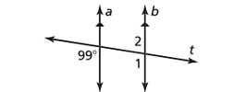  87$°$ | - Use the figure to find the measures of the numbered angles.  $m∠1=$  $m∠2=$  $m∠3=$  $m∠4=$  $m∠5=$  $m∠6=$  $m∠7=$  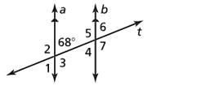  $$9°$$

- Describe the relationship between each pair of angles.
a) $∠6 and ∠2$: ________________________________________

b) $∠7 and ∠5:$________________________________________

BACK
DIRECTIONS: Identify each pair of angles as corresponding, alternate interior, alternate exterior, or (same-side) consecutive interior.
1.  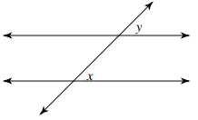 | 2.  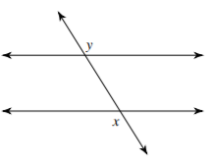 | 3.  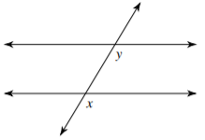
4.  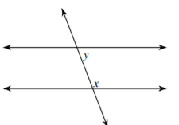 | 5.  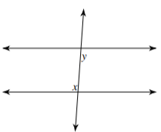 | 6.  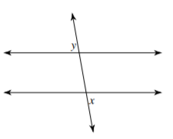

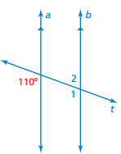
$m∠1=$ $______$ because $____________________________________________$

$m∠2=$ $______$ because $____________________________________________$

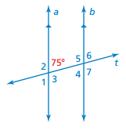
$m∠1=$ $______$ because $_____________________________________________________$

$m∠2=$ $______$ because $_____________________________________________________$

$m∠3=$ $______$ because $_____________________________________________________$

$m∠4=______$ because $_____________________________________________________$

$m∠5=______$ because $_____________________________________________________$

$m∠6=______$ because $_____________________________________________________$

$m∠7=$ $______$ because $_____________________________________________________$

3.1B Lesson Launch
Fill in 1st blank with:  TYPE OF ANGLE PAIR:  - Corresponding  - Vertical  - Alternate Interior  - Alternate Exterior  - Same-Side Interior  - Same-Side Exterior | Fill in 2nd blank with:  THESE ANGLES ARE…  - Congruent  - Supplementary

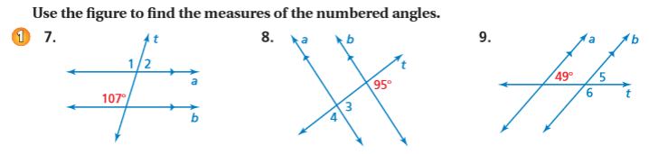

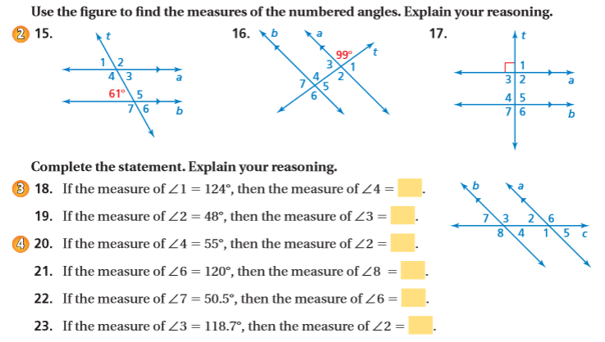

Name: ________________________ Table #: ________ Period: ______ Date: _______
EXIT SLIP 3.1B
Use the figure to find all of the numbered angles. Explain your reasoning.
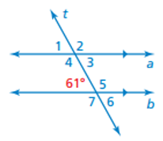 | $∠1= because$________________________________________  $∠2= because$________________________________________  $∠3= because$________________________________________  $∠4= because$________________________________________  $∠5= because$________________________________________  $∠6= because$________________________________________  $∠7= because$________________________________________

Name: ________________________ Table #: ________ Period: ______ Date: _______
EXIT SLIP 3.1B
Use the figure to find all of the numbered angles. Explain your reasoning.
$∠1= because$________________________________________

$∠2= because$________________________________________

$∠3= because$________________________________________

$∠4= because$________________________________________

$∠5= because$________________________________________

$∠6= because$________________________________________

$∠7= because$________________________________________

