Name: ______________________________ Table #:___________ Period: _____ Date: ______
3.1B Parallel Lines And Transversals_Classwork
Objective: Identify angles created when parallel lines are cut by a transversal (CCSS: 8.G.5)
HW: (3.1B) p. 107 #7 - 9, 15 – 23 (Solutions on p. A16)

Read Examples 1 and 2 (p. 104 - 5). Then do On Your Own #1 – 3
- Use the figure to find the measure of the angle. Explain your reasoning.
$m∠1=$ $______$ because $_____________________________________________________$

$m∠2=______$ because $_____________________________________________________$

- Use the figure to find the measures of the numbered angles.
$m∠5=$

$m∠6=$

$m∠7=$

$m∠1=$

$m∠2=$

$m∠3=$

$m∠4=$

- Use the figure to find the measures of  $m∠1=$ $______$ because $______________________________$  $m∠2=$ $______$ because $______________________________$  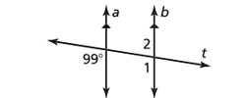 | - Use the figure to find the measures of the numbered angles.  $m∠1=$  $m∠2=$  $m∠3=$  $m∠4=$  $m∠5=$  $m∠6=$  $m∠7=$  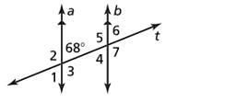

- Describe the relationship between each pair of angles.
a) $∠1 and ∠7$: ________________________________________

b) $∠3 and ∠5:$________________________________________

Video: https://www.bigideasmath.com/protected/content/dcs_cc2/tutorials/mp4/cc12/grade%208/chapter%205/section%205/ltut_8_05_05_2/ltut_8_05_05_2.html

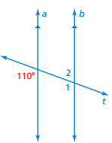
$m∠1=$ $______$ because $____________________________________________$

$m∠2=$ $______$ because $____________________________________________$

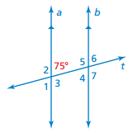
$m∠1=$ $______$ because $_____________________________________________________$

$m∠2=$ $______$ because $_____________________________________________________$

$m∠3=$ $______$ because $_____________________________________________________$

$m∠4=______$ because $_____________________________________________________$

$m∠5=______$ because $_____________________________________________________$

$m∠6=______$ because $_____________________________________________________$

$m∠7=$ $______$ because $_____________________________________________________$

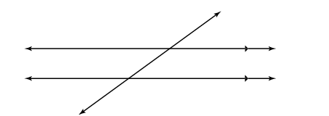

3.1B Lesson Launch
Fill in 1st blank with:  TYPE OF ANGLE PAIR:  - Corresponding  - Vertical  - Alternate Interior  - Alternate Exterior  - Same-Side Interior  - Same-Side Exterior | Fill in 2nd blank with:  THESE ANGLES ARE…  - Congruent  - Supplementary

