Name: _________________________ Table #: ________Period: ______ Date: ______
3.1B Translating Algebraic Expressions_Classwork
Objective: apply properties of operations to simplify algebraic expressions; solve real-life problem.
CC.SS.7.EE.1 and CC.SS.EE.2
DIRECTIONS: translating each of the following into an expression.
 | Algebraic Expression | Verbal Expression | Coefficient
1 | x – 5
2 |  | 5 more than twice x
3 | 5 + 3x
4 |  | The difference of -17 and 5 times a number
5 | 5x²
6 |  | 5 less than x
7 | x² – 2
8 |  | The sum of x and twice y
9 | 3 – 5x
10 |  | The product of -5 and x squared
11 | 5 + 2x
12 |  | 3 decreased by the product of 5 and x
13 | 5x² – 2
14 |  | The sum of x to the second power and 3 times y
15 | 3x² – y
16 | x + 5
17 |  | 2 less than x to the second power
18 | x² + 3y
19 |  | The product of 5 and x
20 |  | 5 increased by 3 times a number
21 | x + 2y
22 | 5x
23 |  | The quotient of a number and 5
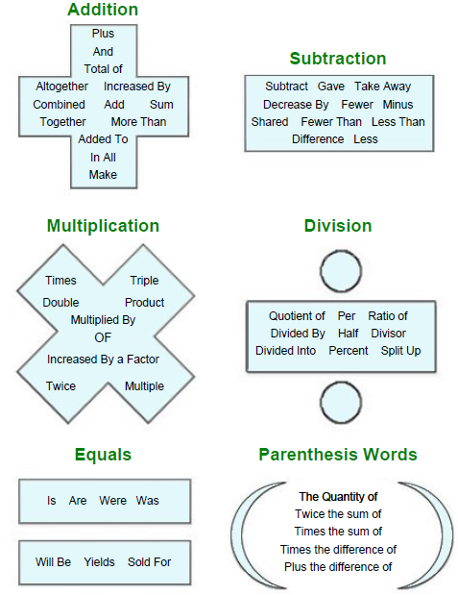

Homework: worksheet- 3.1B HW

