Name: _________________________ Table #: ________Period: ______ Date: ______
3.1C Combing Like Terms_Classwork
Objective: apply properties of operations to simplify algebraic expressions; solve real-life problem.
CC.SS.7.EE.1 and CC.SS.EE.2

Vocabulary

Opposite:

Like Terms:

Example 1: Identify the Terms and like terms in the expression.
- $3x+4-7x-6$  Terms:  Like Terms: | - $-9+2.5y-3y+1+6.4y^{2}$  Terms:  Like Terms: | - $xy+1.5y-2xy+3.3-5.2$  Terms:  Like Terms:

An algebraic expression is in _______________ ___________ when it is no like terms and no parentheses. To combine like terms that have variables, use the Distributive Property to add or subtract the coefficients.

Example 2: Simplify the expression
- $3x+4-7x-6$ | - $-9+2.5y-3y+1+6.4y^{2}$ | - $xy+1.5y-2xy+3.3-5.2$

ON YOUR OWN: Simplify the expression.
- $12g+9g$ | - $11x+9--7$ | - $8m-11m+6$
- $4.2v-5--6.5v$ | - $-8+4n+6.2-9n$ | - $\frac{2}{5}y-4+7-\frac{1}{5}y$
Example 3: Write the sum and then write an equivalent expression by collecting like terms.
- 2x and -2x + 3 | - 2x – 7 and the opposite of 2x | - The opposite of (5x – 1) and 5x

Example 4: Critical Thinking
- Explain why the two expressions are not equal to each other. $2x+4y≠6xy$ | - Is xy the same as yx? Explain.
- Explain Sally’s mistake in the following problem.  $$Problem: 8x+6x+2$$  $$her answer:16x$$ | - Jose and Amy were asked to combine $7x+2y+6y+3x.$ Decided who is correct. Explain.  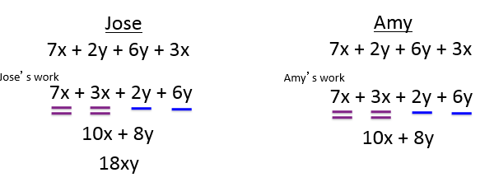

Homework: worksheet- 3.1C HW #1-14 ALL

