Name: ______________________ Table #:___________ Period: ______ Date: _______
3.1E Perimeters and Areas in Algebraic Expressions _Classwork
Objective: use combing like terms and distributive property to find perimeters and areas.
HW: 3.1E worksheet

- Find the algebraic expressions for the perimeter and area of each rectangle.
Perimeter: __________ Perimeter: __________ Perimeter: __________
Area: ______________ Area: ______________ Area: ______________

- Find the algebraic expressions for the perimeter and rea of these rectangles.
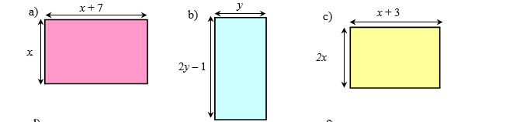
Perimeter: __________ Perimeter: __________ Perimeter: __________
Area: ______________ Area: ______________ Area: ______________

- Bob mowed (2x² + 5x – 3) yards on Monday, (4x – 7) yards on Tuesday, and (3x² + 10) yards on Wednesday.
  - How many yards did he mow in the three days?

  - If Bob mowed 14x² + 12x – 3 yards total for the entire week, how many yards did he mow during the rest of the week?

- Molly has (4x + 10) dollars and Ron has (20 – 5x) dollars.
  - How much money do they have altogether?

  - How much more money does Molly have than Ron?

- Ross has (8x – 5) tickets for Chuck E Cheese. He is going to play today and wants to buy a prize that is (15x + 1) tickets. How many tickets must he win to have enough tickets to buy the prize?

EXTRA CREDITS
- Find the algebraic expressions for the perimeter of these shapes.
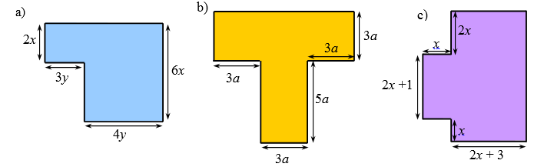
Perimeter: __________ Perimeter: __________ Perimeter: __________

