Name: __________________________ Table #:_________ Period: _______ Date: ________
3.2A Adding and Subtracting Linear Expressions_Classwork
Objective: compare and contrast between linear expressions and nonlinear expressions; add and subtract linear expressions; solve-real life applications. https://www.youtube.com/watch?v=vah7-2jumVs

A linear expression is special because:
- It has ____ variable.
Example: Non-Example:

- No variable in a linear expression is raised to a power greater than ____ or used as the denominator of a fraction
Example: Non-Example:

- Linear expressions graph has ____________ ____________.
Example: Non-Example:

ACTIVITY: Place each expression in the correct box.
Linear Expressions | Nonlinear Expressions

Example 1: $\left(x-2\right)+(3x+8)$ | Example 4: $\left(4-5y\right)-(2y-8)$
Example 2: $\left(-4y+3\right)+(11y-5)$ | Example 5: $\left(4.2-5y\right)-(2y-8.6)$
Example 3: $2\left(-7z+3\right)+(5z-2)$ | Example 6: $\left(4-5.6y\right)-2(1.7y-6)$
HW: worksheet: 3.2A HW https://www.livingston.org/cms/lib4/NJ01000562/Centricity/Domain/564/adding%20and%20subtracting%20linear%20expressions%20worksheet.pdf
WARM-UP
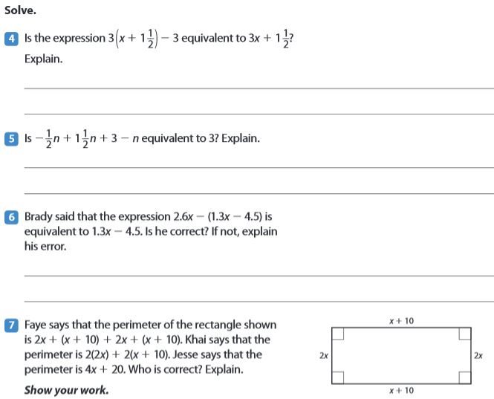
4)
3)
2)
1)

Possible homework: Homework: 3.2B pg 90_#8-13 ALL and #19-22 ALL https://static.bigideasmath.com/protected/content/rpj/ca/red_journal_03.pdf
Print: http://images.pcmac.org/SiSFiles/Schools/TN/BradleyCounty/LakeForestMiddle/Uploads/DocumentsCategories/Documents/Lesson_15_HW.pdf

