Name: _________________ Table #:___________ Period: _____ Date: ______
3.2A NOTES – Angles of Triangles

Objective: Find the measures of interior and exterior angles of triangles (CCSS: 8.G.5)
HW: (3.2) p. 114 #1 – 3 all, 5 – 9 odd, 12 – 15 all (solutions on p. A17)
LESSON OPENER: Work with a partner to find the missing angle measures
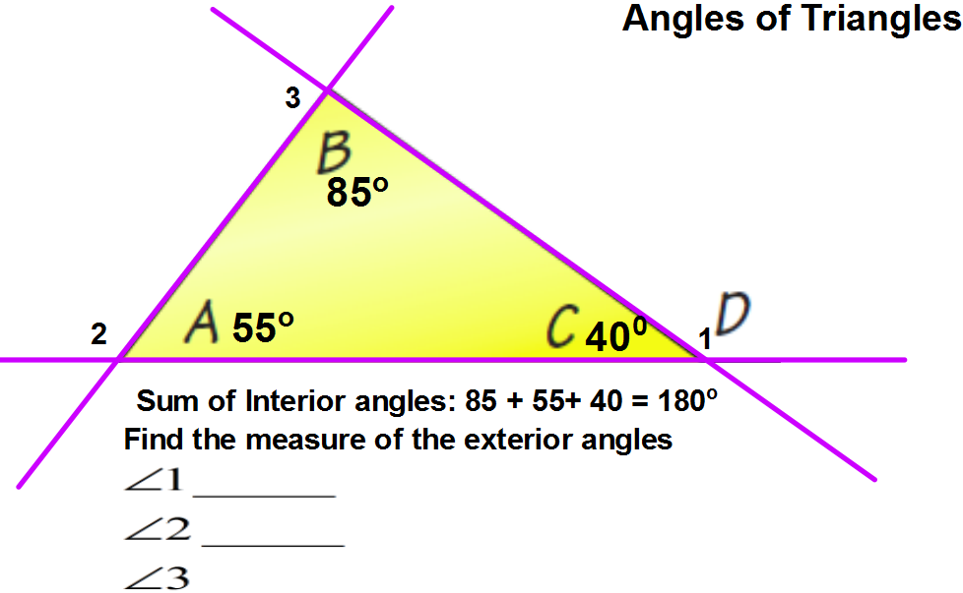
The sum of all 3 interior angles in a triangle is 180°

$m∠1=______$ $m∠2=$ $______$ $m∠3=______$

What do you notice about the sum of two interior angles and one exterior angle?

Read Examples 1 – 3 (p 112 – 4). Then do the problems below
Example 1:  Find the value of x.  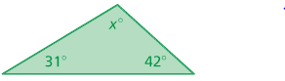 | Example 2:  Find the value of x.  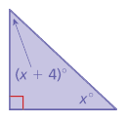
Example 3:  Find the measure of the exterior angle (x).  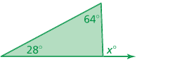 | Example 4:  - Find the value of “a” _________  - Find the measure of the exterior angle. _______  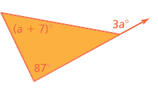
BACK
Example 5:  Find the measure of the exterior angle (x). | Example 6:  - Find the value of “a” _________  - Find the measure of the exterior angle. _______
Example 7:  A car travels around the park shown below.  - What is the value of “x”? _________  - What are the interior angle measurements of the park? __________________________ | Example 8:  An airplane leaves from Miami and travels around the Bermuda Triangle.  - What is the value of “x”? _________  - What are the interior angle measurements of the Bermuda Triangle? _______________  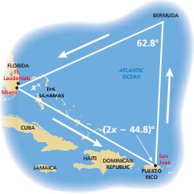
Video: https://www.youtube.com/watch?v=DI_Bh6XmINU
https://www.youtube.com/watch?v=nvrgkKIVvnU

