Name: _______________________ Table #: _______ Period: ___________ Date: ___________
NOTES 3.2B – Exterior Angles of Triangles

Objective: Find the measures of exterior angles of triangles by writing and solving equations. (CCSS: 8.G.5)
HW: 3.2B Homework (handout)

p. 112 -- EXTERIOR ANGLE MEASURES OF A TRIANGLE
The measure of an exterior angle of a triangle is equal to the sum of the measures of the two nonadjacent interior angles.
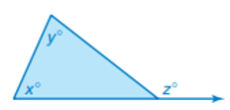 z = x + y

Example 1: Find the value of n. Then find the measure of the exterior angle.
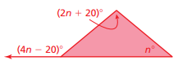

Example 2: Find the value of a. Then find the measure of the exterior angle.
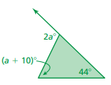

Example 3: Write an equation for the value of y in terms of x. Then solve the equation for x.
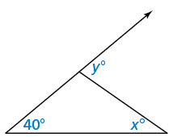
$$50°$$

BACK

ON YOUR OWN
- Find the value of x. Then find the measure of the exterior angle.
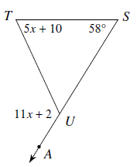

- Find the value of x.
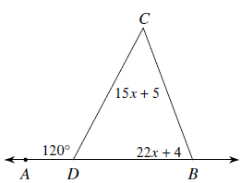

- Write an equation for the value of y in terms of x. Then solve the equation for x.
$$45°$$

Solutions to 3.2B HW:
- 10, 70º, 60º 2) 4, 40º, 28º 3) 5, 55º, 70º 4) 15, 60º, 90º
5) 24, 48º, 95º 6) 12, 36º, 86º 7) 15, 30º, 23º 8) 10, 63º, 73º
9) 20, 80º, 59º 10) 25, 25º, 125º 11) 40, 84º, 41º 12) 11, 44º, 73º

