Name: __________________ Table #:_____ Period: _____ Date: ______
3.3A Interior Angles of Polygons_Classwork
Objective: Discover the sum of the interior angle measures of polygons. Find the measures of interior angles of polygons. (CCSS: 8.G.5)

Choose one vertex and draw all possible diagonals from that vertex
Convex Polygon Name | Diagram | Numbers of Sides | Number of Diagonals From One Vertex | Number of Triangles | Sum of Interior Angles
Quadrilateral
Pentagon | 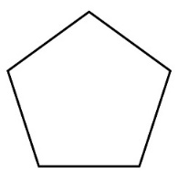
Hexagon
heptagon | 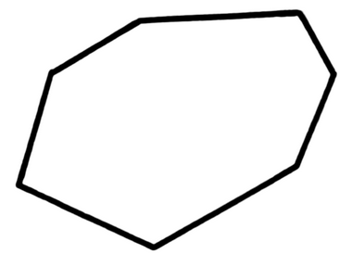
Octagon

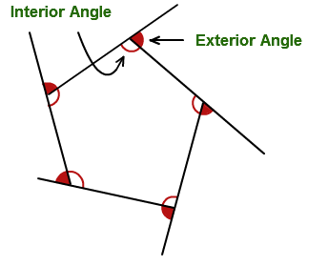
Theorem of the Interior Angles of a Polygon:

Example 1: Find the sum of the interior angle measures of the polygon.  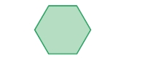 | Example 2: Find the sum of the interior angle measures of the polygon.
Example 3: Find the value of x. | Example 4: Find the value of x.
Example 5: Find the value of x. | Example 6: Find the value of x.  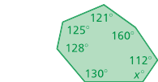
Example 7:  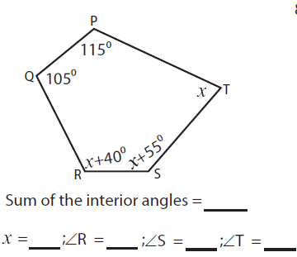 | Example 8:  