Name: ____________________________ Table #: __________ Period: _______ Date: ______

**3.3A HW**

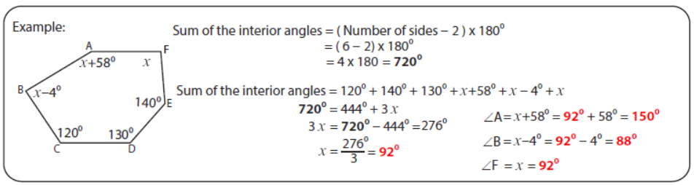

|  |  |
| --- | --- |
| 1. | 2. |
| 3. | 4. |