Name: _________________________ Table #: _______ Period: _______ Date: _______
3.3A NOTES – Angles of Polygons
Objective: Discover the sum of the interior angle measures of polygons. Find the measures of interior angles of polygons. (CCSS: 8.G.5) HW: (3.3A) p. 123 #4 – 14 (copy the figures if you are doing on paper and not in BIM)

DIRECTIONS
- Draw a line segment on the figure that divides it into triangles.
- LINE SEGMENTS MUST NOT INTERSECT.
- How many triangles can divide each figure?
- If the sum of the interior measures in a triangle are 180º, what is the sum of the interior angle measures of each figure?
Convex Polygon Name | Diagram | Numbers of Sides | Number of Triangles |  | Sum of Interior Angles
Quadrilateral
Pentagon | 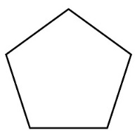
Hexagon | 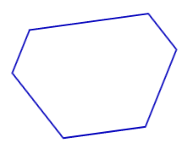
Heptagon | 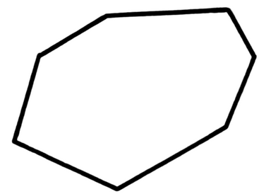
Octagon | 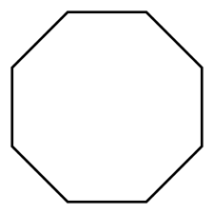
PROBLEM 1A:  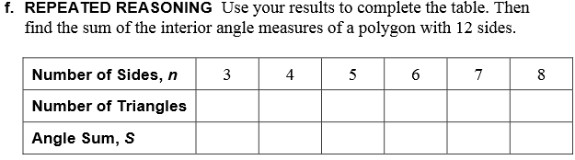 |  |  |  | PROBLEM 1B:  Find the sum of the interior angles or a 12 sided polygon.

INTERIOR MEASURES OF A POLYGON (p. 120)

The sum ___ of the INTERIOR ANGLES of a polygon with ____ sides is S = ( ) ∙ 180
Example 1  - Find the sum of the interior angle measures of a 19 sided polygon.  - Find the sum of the interior angle measures of a 29 sided polygon. | Example 2  Find the value of x  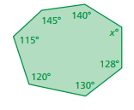
Example 3:  Find the value of x and the missing angles.  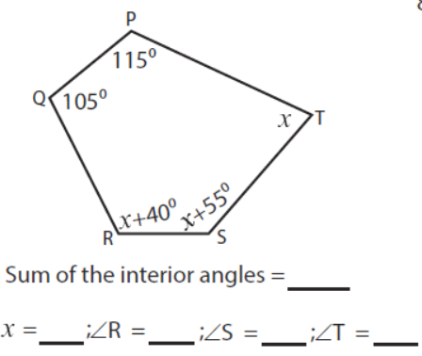 | Example 4:  Find the value of x and the missing angles.  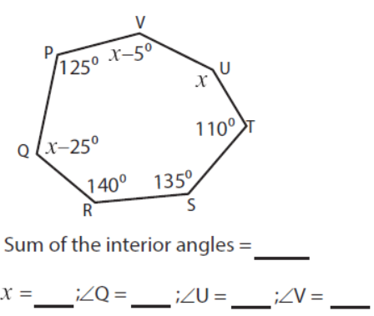

ON YOUR OWN
#1: Find the value of x.  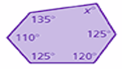 | #2: Find the value of x.  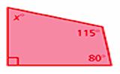 | #3: Find the value of x and the missing angles.  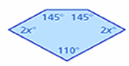
Beginning of lesson (Review for 3.1-3.2 Quiz)
- Describe the relationship between each pair of angles. (corresponding, alternate interior, alternate exterior, vertical, or no relationship)
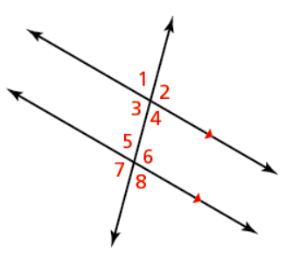
- $∠2=∠7$ ______________________________

- $∠1=∠5$ ______________________________

- $∠4=∠5$ ______________________________

- $∠1=∠6$ ______________________________

- $∠5=∠8$ ______________________________

If the measure of $∠1$ is equal to 110º, find the measure of the other angles.
 | $∠2= ____$  $∠3= ____$  $∠4= ____$  $∠5= ____$  $∠6= ____$  $∠7= ____$ | $∠2= ____$ because _________________________________  $∠2= ____$ because _________________________________ | $∠2= ____$ because _________________________________  $∠2= ____$ because _________________________________

