Name: _________________________ Table #: _______ Period: _______ Date: _______

3.3B NOTES – Angles of Polygons
Objective: Use the sum of 360º for the exterior angle measures of polygon to find missing angle measures. Find the measure of each interior angle of a regular polygon (CCSS: 8.G.5)
HW: (3.3B) p. 124 #16 –24 (If you are doing on paper, copy the figures)
https://www.youtube.com/watch?v=BG1HpadfiKw&feature=youtu.be
REVIEW: In a REGULAR POLYGON, all the sides are congruent, and all the interior angles are congruent. Find the measure of each interior angle of a regular hexagon.
Step 1: Find the sum of the interior angles; use the formula:
S = (n – 2) $∙$180

Step 2: Find the measure of each interior angle:
Sum of interior angles ÷ n

Find the measure of each interior angle of the regular polygon.
- Octagon | - Decagon | - 18-gon

Key Ideas: Exterior Angle Measures of A Polygon
WORDS: The sum of the measures of the __________________ angles of a convex polygon is _____________________.

ALGEBRA: w + x + y + z = _______________

READ EXAMPLE 4 (P. 122) and then do On Your Own #9
Example 1: Find the measures of the exterior angles of the polygon.
Example 2: Find the measures of the exterior angles of each polygon.

Example 3: Find the measures of the exterior angles of each polygon.

Example 4: Find the measures of the exterior angles of each polygon.
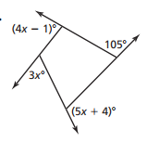
Example 5: Find the measures of the exterior angles of each polygon.
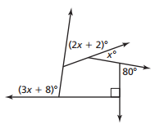

Example 6: The interior angles of a regular polygon each measure 144º. How many sides does the polygon have? | Example 7: The interior angles of a regular polygon each measure 120º. How many sides does the polygon have?

