Name: _______________________ Table #: _______ Period: ___________ Date: ___________
3.4A NOTES – Application Problems Using Similar Triangles
Objective: Use indirect measurement to find missing measurements of similar triangles. CC.SS.8.G.5
HW: 3.4A Homework (handout)
(Review):  The triangles are similar. Find x.  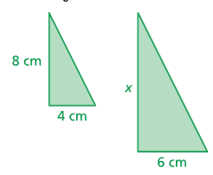 | Warm Up #1.  The triangles are similar. Find x.  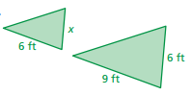
Examples 1 and 2 show similar triangles. Write proportions to solve unknown measurements.
Example 1:
Find the height of the giraffe in the diagram below. The person in the diagram is 5.5 feet tall.

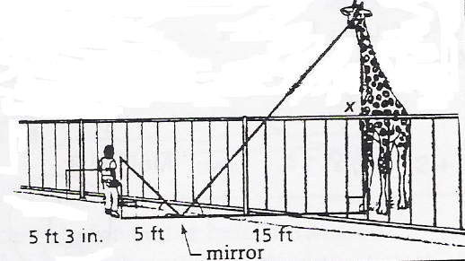
ANSWER: _____________
Example 2:
On level ground, the base of a tree is 20 ft from the bottom of a 48-ft flagpole. The tree is shorter than the pole. At a certain time, their shadows end at the same point 60 ft from the base of the flagpole. How tall is the tree? Hint: draw two triangles and label again.

ANSWER: _____________
Example 3 (Similar Test Question #20):
A 5-foot tall pole creates a shadow that is 4 feet long. At the same time, a road sign creates a shadow that is 10 feet long. How tall is the road sign? HINT: Draw a picture

ANSWER: ____________
BACK
ON YOUR OWN
- If a tree casts a 24-foot shadow at the same time that a yardstick casts a 2-foot shadow, find the height of the tree.
3 ft
2 ft
24 ft
x ft

ANSWER: _____________
- Triangle ABC is similar to triangle DEC. Use what you know about corresponding sides of similar triangles to find the height of the tree. HINT: Write a proportion.
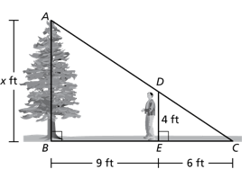

ANSWER: _____________
- Ramon places a mirror on the ground 45 ft from the base of a geyser. He walks backward until he can see the top of the geyser in the middle of the mirror. At that point, Ramon’s eyes are 6 ft above the ground and he is 7.5 ft from the mirror. Use similar triangles to find the height of the geyser.
x ft
45 ft
7.5 ft
6 ft

ANSWER: _____________
- A hedge is sighted on the other side of a canyon. Find the width of the canyon.
100 ft
10 ft
7.5 ft
x

ANSWER: _____________

