Name: ___________________________________ Table # ___ Per ______ Date ____________
3.4A Homework
(Writing proportions for problems involving similar triangles)
- A flagpole casts a 20-foot shadow. At the same time, Shane, who is 6 feet tall, casts a 5-foot shadow. What is the height of the flagpole? Assume the triangles are similar.
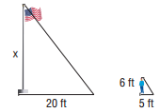
ANSWER: _____________

- Ruth is at the park standing next to a slide. Ruth is 5 feet tall, and her shadow is 4 feet long. If the shadow of the slide is 4.8 feet long, what is the height of the slide? Assume the triangles are similar.
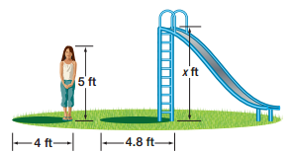
ANSWER: _____________

- You place a mirror on the ground 6 feet from the lamppost. You move back 3 feet and see the top of the lamppost in the mirror. If you are 5 feet tall, what is the height of the lamppost?

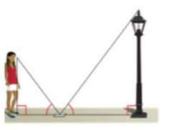
ANSWER: _____________

- A 6-foot tall pole creates a shadow that is 2.5 feet long. At the same time, a road sign creates a shadow that is 11 feet long. How tall is the road sign? HINT: Draw a picture

ANSWER: _____________

BACK
- Catarina’s boat has come untied and floated away on the lake. She is standing atop a cliff that is 35 feet above the water in a lake. If she stands 10 feet from the edge of the cliff, she can visually align the top of the cliff with the water in a lake. Is she stands 10 feet from the edge of the cliff, she can visually align the top of the cliff with the water at the back of her boat. Her eye level 5.5 feet above the ground. Approximately how far out from the cliff is Catarina’s boat? Round to the nearest tenth.
5.5ft
10 ft
35 ft

ANSWER: _____________

- Dennis needs to fix a leaky roof on his house but does not own a ladder. He thinks that a 25-foot ladder will be long enough to reach the roof, but he needs to be sure before he spends the money to buy one. He chooses a point P on the ground where he can visually align the roof of his car with the edge of the house roof. Will a 25-foot ladder be long enough for Dennis to safely reach his roof?
HINT: 12 inches = 1 foot
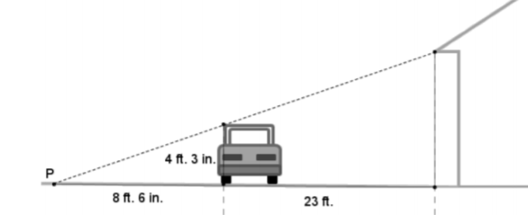
51 in
276 in
102 in

ANSWER: _____________

- Triangles EFG and QRS are similar. The length of the sides of EFG are 144, 128, and 112. The length of the smallest side of QRS is 280, what is the length of the longest side of QRS? HINT: Draw a diagram and solve.

ANSWER: _____________

Solutions: 1) 24 2) 6 3) 10 4) 26.4 5) 63.6 6) yes 7) 360

