Name: ______________________________ Table #: _______ Period: _______ Date: _______

**3.4A Using Similar Triangles_Classwork**

*Objective: identifying similar triangles using AA Postulate CC.SS.8.G.5*

|  |
| --- |
| **Angles of Similar Triangles (AA Postulate)**  **Word:** When two angles in one triangle are _______________________ to two angles in another triangle, the  third angles are also ________________ and the two triangles are _______________.  **Symbol:** Triangle ABC is similar to Triangle DEF, $∆ABC\sim ∆DEF$ **Example:** |

***Tell whether the triangles are similar. Explain.***

|  |  |
| --- | --- |
| a. | b. |
| c. | d. |
| e. | f. |

Name Date

Practice Problems

For use after Lesson 3.4

3.4

Tell whether the triangles are similar. Explain.

1. 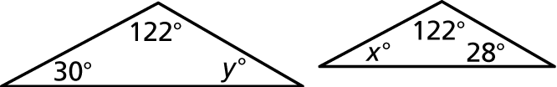 2. 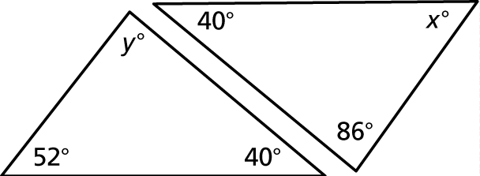

3. 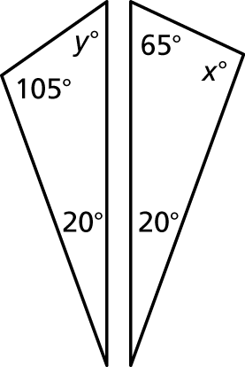 4. 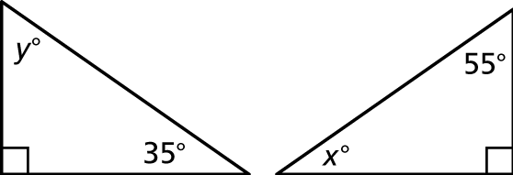

5. You can use similar triangles to find the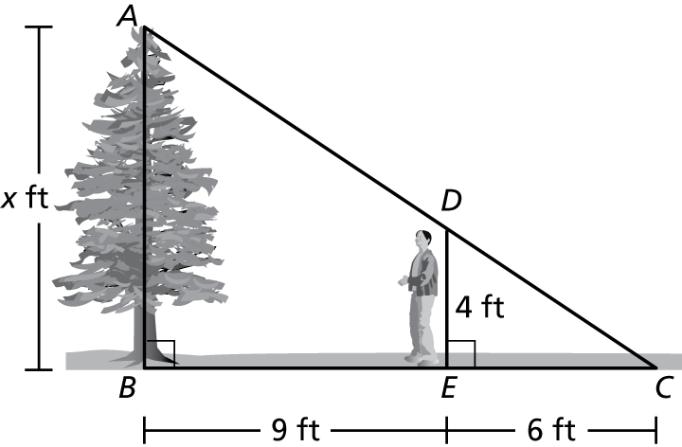  
height of a tree. Triangle *ABC* is similar  
to triangle *DEC*. What is the height of   
the tree

