Name: ____________________________ Table #: _______ Period: _______ Date: _______

3.4B Application Problems Using Similar Triangles_Classwork

Objective: apply similar triangles to solve missing length. CC.SS.8.G.5

- If a tree casts a 24-foot shadow at the same time that a yardstick casts a 2-foot shadow, find the height of the tree.
3 ft
2 ft
24 ft
x ft

- A bush is sighted on the other side of a canyon. Find the width of the canyon.
100 ft
10 ft
7.5 ft
x

- You place a mirror on the ground 6 feet from the lamppost. You move back 3 feet and see the top of the lamppost in the mirror. If you are 5 feet tall, what is the height of the lamppost?

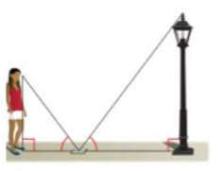

- Ramon places a mirror on the ground 45 ft from the base of a geyser. He walks backward until he can see the top of the geyser in the middle of the mirror. At that point, Ramon’s eyes are 6 ft above the ground and he is 7.5 ft from the mirror. Use similar triangles to find the height of the geyser.
x ft
45 ft
7.5 ft
6 ft

Example 1:
Find the height of the giraffe in the diagram below. Hint: convert into inches when solving to problem, but your final answer should be in feet.

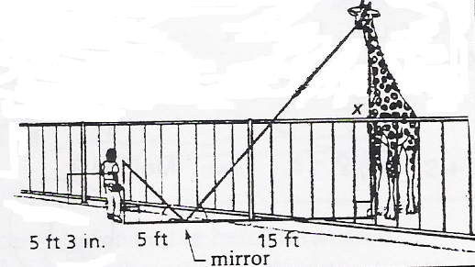

Example 2:
On level ground, the base of a tree is 20 ft from the bottom of a 48-ft flagpole. The tree is shorter than the pole. At a certain time, their shadows end at the same point 60 ft from the base of the flagpole. How tall is the tree? Hint: draw two triangles and label again.

Example 3:
Tell whether the triangles or similar or not similar.
1. | 2. | 3.

Warm Up:
1.  The triangles are similar. Find x.  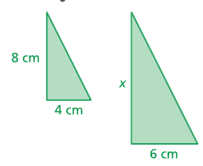 | 2.  The triangles are similar. Find x.  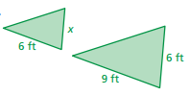
3. Use the figure to find the measures of the numbered angles.
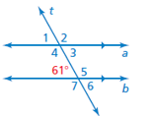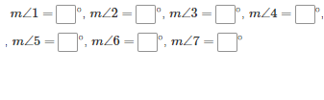
Match the correct explanation to the angles below. Write the letter on the lines below.
STATEMENTS: EXPLANATIONS:
$∠$ 1 is ____ a. corresponding with $∠ 5$
$∠$ 2 is ____ b. corresponding with $∠ 6$
$∠$ 3 is ____ c. corresponding with $∠ 7$
$∠$ 4 is ____ d. corresponding with the given angle
$∠$ 5 & 7 are ____ e. vertical to the given angle
$∠$ 6 is ____ f. supplementary to the given angle.

