Name:_____________________________ Table #:________________ Period:________ Date:________
3.4B HW

- Find the sum of the interior angles measures of the polygon.

ANSWER: _________________________________

- Find the value of x.

ANSWER: _________________________________

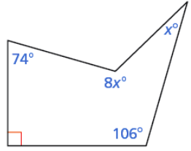

- Find the measure of each interior angle of the regular polygon. Round your answer to the nearest tenth, if necessary.

ANSWER: _________________________________

- Find the value of x.

ANSWER: _________________________________
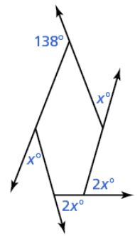 BACK
- Tell whether the triangles are similar.

ANSWER: _________________________________
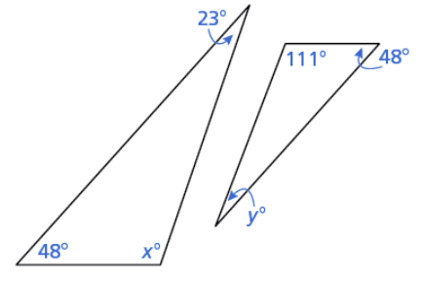

- Tell whether the triangles are similar.

ANSWER: _________________________________
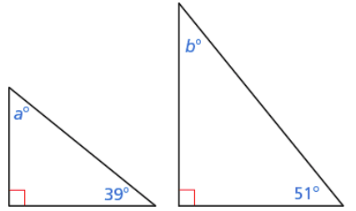

- Find the value of x.

ANSWER: _________________________________
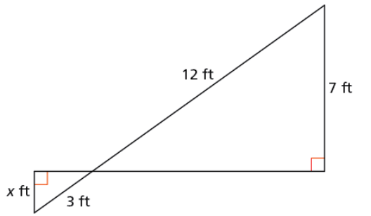

- A swimming pools is in the shape of a regular decagon. One edge of the pools is directly against the outside wall of a house. Find the measure x of the angle between the house and the pool.

ANSWER: _________________________________

From online BIM quiz #3.3-3.4

