5. Use the figure to find all of the numbered angles. Explain your reasoning.
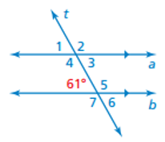 | $∠1=______ because$__________________________________  $∠2=______ because$_________________________________  $∠3=______ because$_________________________________  $∠4= ______ because$_________________________________  $∠5=______ because$_________________________________  $∠6= ______ because$_________________________________  $∠7=______ because$_________________________________

6. Find the measure of the exterior angle.
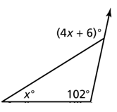

X = _______________ Exterior angle = ____________

7. Find x and the measures of the exterior angles.
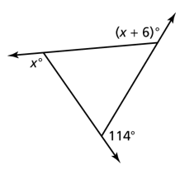

X = ___________ exterior angles: _____, ________, ________

8. Can a hexagon have angles that measure $69°, 85°, 62°, 95°, 173°, 160°?$ Explain

Name: ________________________ Table #:_____ Period: _______ Date: ______
3.4C Review
- Tell whether the triangles are similar or not similar.

$$34°$$
$$57°$$

$$91°$$

- Tell whether the triangles are similar or not similar.
$$106°$$

$$45°$$

- Tell whether the triangles are similar or not similar.

$$29°$$

$$47°$$
$$97°$$

- Tell whether the triangles are similar or not similar.
$$39°$$
$$90°$$

