Name: ______________ Table #: ______ Period: ______ Date: ____
3.5A Solving Two-Step Equations_Classwork
REVIEW

Evaluate the expressions below. Show your steps
1) $5∙6+4$ 2) $5+6∙4$

3. For problem 1 and 2, did you get the same value for both expressions? ________________________________

4. Which operation did you perform first in each expression? Why? _____________________________________

Vocabulary
Chose the best term from the list to complete each sentence.
*isolate the variable *equation *inverse operations

- _________________________ are mathematical operations that undo each other.
- To solve an equation you need to _______________________________________.
- A(n) _______________________ is a mathematical statement that two expressions are equivalent.

Solve Two-Step Equations:
1. use order of operations to simply PEMDAS
2. use distributive property 2(x+3) = 2x + 6 to simplify
3. undo ADDITION/SUBTRACTION (remove constant terms)
4. undo the MULTIPLICATION/DIVISION (to remove coefficient)

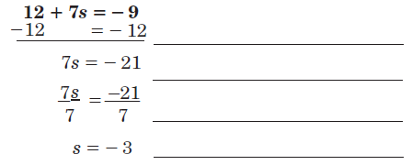

Solve each equation. Show your check.
- $15x+3=48$ Check | - $\frac{t}{4}-10=-6$ Check
- $\frac{b}{3}+13=11$ Check | - $9g+11=2$ Check
- $3.2x-4=12$ Check | - $\frac{m}{3}+2.7=5$ Check
- $-16+\frac{n}{4}=-32$ Check | - $-g+1.5=2$ Check

