Name: _________________________ Table #: _______ Period: ______Date: ________
_____/10 pts
4.1-4.2 Review_Classwork
1.
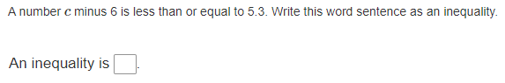
2.
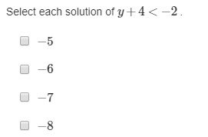
3.
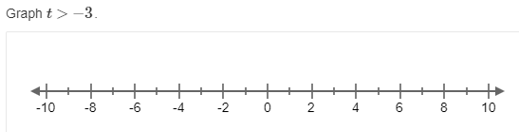
4.
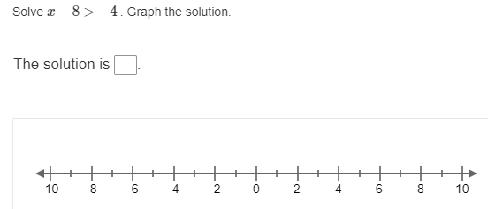
5.

6.
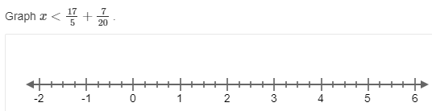
7.
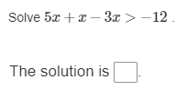
8.
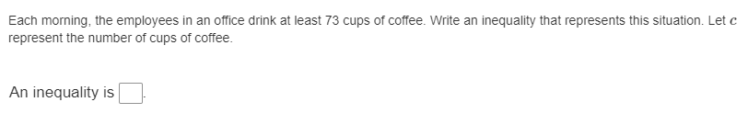
9.
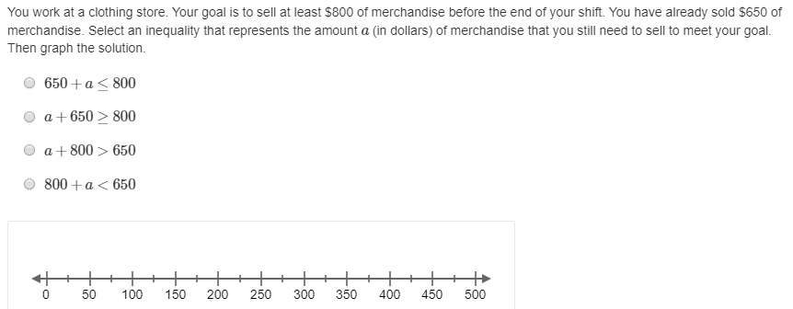

10.
