Name: _________________________ Table #: _______ Period: ______ Date: ________
4.1A Writing Inequalities_Classwork
Objective: write and graph inequalities; use substitution to check whether a number is a solution of an inequality. Preparing for Standard 7.EE.4b HW: 4.1A pg 128_ #6-15 ALL

Read the statement. Circle each number that makes the statement true, and then answer the questions.
- Why the number included or not included. 2) Write four other numbers that make the statement true.

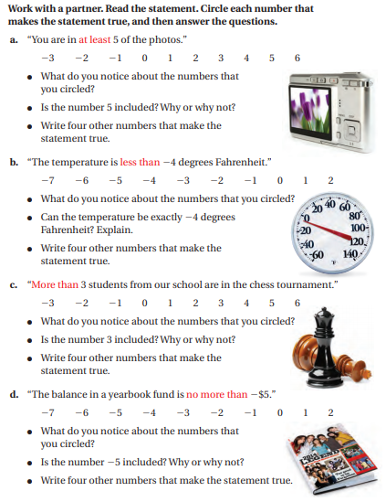

An _____________________________ is a mathematical sentence that compares expressions. It contains the symbols _______, _______, _________, or ________. To write an inequality, look for the following phrase to determine where to place the inequality symbol.
SMYBOL | MEANING | WORD PHRASES
$$<$$ | Is less than | Fewer than, below, is under, shorter than, smaller than, lower than, beneath, a better deal
$$>$$ | Is greater than | More than, exceed, above, over, larger than, increased, higher than
$$≤$$ | Is less than or equal to | At most, no more than, maximum, up to
$$≥$$ | Is greater than or equal to | At least, no less than, minimum
Writing Inequalities
Inequality Word Statements: Write each statement with an inequality.
- A number “x” is no more than -3.45. ______________
- The product of 3 and (3x + 1) is at least 35. ______________
- The minimum value of 2x + 1 is 13. ______________
- When “x” is divided by 3 the quotient is more than 5. ______________
- 10 is more than a number “m” times 50. ____________
- A number “b” minus 4.3 is less than -9.8 . ______________
- A number “m” multiplied by -3.5 is at least $\frac{2}{5}.$ ______________
- A number “m” times five is at most fifteen. ______________
- A number “x” minus negative seven is less than or equal to five. ______________
- The difference between a number “r” and seven is less than zero. ______________
- The sum of a number “w” and seven is greater than or equal to fifteen. ______________
- A number “x” is no less than fifteen. ______________
- Twice a number “x” is less than twenty. ______________
- The sum of a number “m” and nine is larger than thirty. ______________

A ________________________ is a value that makes the inequality true. An inequality can have more than one solution. The set of all solutions of an inequality is called the __________________________________.

Tell whether each x value is a solution of following inequalities:
Value of x $$x+12>7$$ Is the inequality true?  -2  -8  5 | Value of x $$\frac{x}{6}>-3$$ Is the inequality true?  2  -3  -24

