Name: _______________ Table #: ______ Period: _______ Date: ______
4.1B Graphing Horizontal and Vertical Lines_Classwork

Objective: Graph linear equations using a point and a slope; graph linear equation using two points.
(CCSS: 8.EE.5)
HW: textbook- 4.1B pg 146_#1-4, #10-17

DIRECTION: If not given, state whether the line has a slope of Zero or Undefined. Also, state whether it is a Horizontal or a vertical line. Graph the line.

EXAMPLE 1: (7, 8) and (1,8)  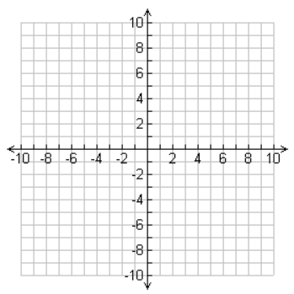  Type of slope: ________________  Type of line: _________________ | EXAMPLE 2: (6, 2) and m = 0  Type of slope: ________________  Type of line: _________________ | EXAMPLE 3: (-2, -3) and undefined  Type of slope: ________________  Type of line: _________________
- (4, -1) and (4, 4)  Type of slope: ________________  Type of line: _________________ | - (6, 4) and (3, 4)  Type of slope: ________________  Type of line: _________________ | - (-5, 6) and (-5, -9)  Type of slope: ________________  Type of line: _________________
- (-2, -5) and slope = 0  Type of slope: ________________  Type of line: _________________ | - (-4, 5) and (4, 5)  Type of slope: ________________  Type of line: _________________ | - (-2, 0) and slope = 0  Type of slope: ________________  Type of line: _________________
- (2, -5) and m = undefined  Type of slope: ________________  Type of line: _________________ | - (2, 5) and m = 0  Type of slope: ________________  Type of line: _________________ | - (3, -1) and (3, -4)  Type of slope: ________________  Type of line: _________________
- (5, -3) and slope = zero  Type of slope: ________________  Type of line: _________________ | - (5, 8) and (-2, 8)  Type of slope: ________________  Type of line: _________________ | - (-6, -6) and undefined  Type of slope: ________________  Type of line: _________________

