Name: _________________________ Table #: _______ Period: ______ Date: ________
4.1B Graphing Inequalities_Classwork

Objective: graph and identify equation and inequalities as points and rays on a number line.
HW: textbook: 4.1B pg 128_#17-25 ALL

The _________________ of an inequality shows all of the solutions of the inequality on a number line.
- An open circle _________ is used when a number is not a solution
- A closed circle _________ is used when a number is a solution.
- An arrow to the left or right shows that the graph continues in that direction.
$$<$$  Open Circle | $$>$$  Open Circle | $$≥$$  Closed Circle | $$≤$$  closed Circle

Draw a graph for each inequality.
1.  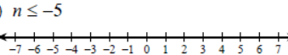 | 2.  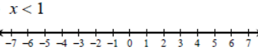
3.  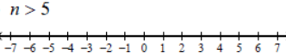 | 4.  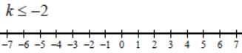
5.  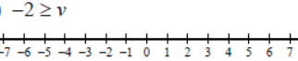 | 6.  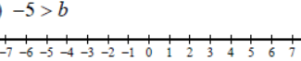
7.  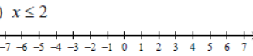 | 8.  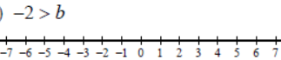

Write an inequality for each graph.
1.  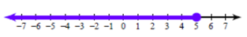 | 2.  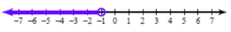
3.  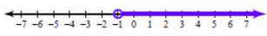 | 4.  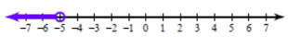
5.  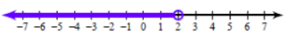 | 6.  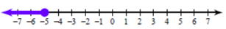

WARM-UP
Tell whether the given value is a solution of the inequality. Write TRUE or FALSE after you solve each problem.
- $2k-4<7; k=5$ | - $\frac{w}{4}≥w-12; w=20$ | - $8-y>2y; y=-1$

