Name: __________________________ Table #: ___________ Period: ____________ Date: ______
4.2A The Slope Formula_Classwork
Objective: find slopes of lines by using two points
HW: 4.2A pg 154_#1, 3, #7-18 ALL

EXAMPLE 1: Given the slope (m) and the y-intercept (b), write a linear function for each problem.
- m = 3; b = -3 | - m = $-\frac{1}{3}$; b = 2 | - m = 0; b = 4
- m = $\frac{3}{4}$; b = 0 | - m = -1; b = 6 | - m = -5; b = -2

EXAMPLE 2: Use the FORMULA $\frac{Y_{2}-Y_{1}}{X_{2}-X_{1}}$to find the slope. Use two points to find the slope.
- (-3, 5) and (2, 18) | - (3, -3) and (3, -1) | - (4, -3) and (2, -3)
- (5, -1) and (9, -4) | - ( 5, 2) and (1, 0) | - (0, 0) and (3, -1)
- (9, 2) and (8, -7) | - (-4, 4) and (-7, 2) | - (1, 0) and (3, -4)

WARM-UP
Find the slope and y-intercept for each problem.
1.  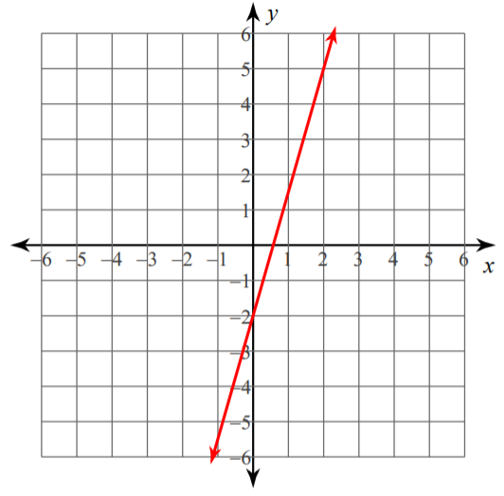  Slope: y-intercept: | 2.  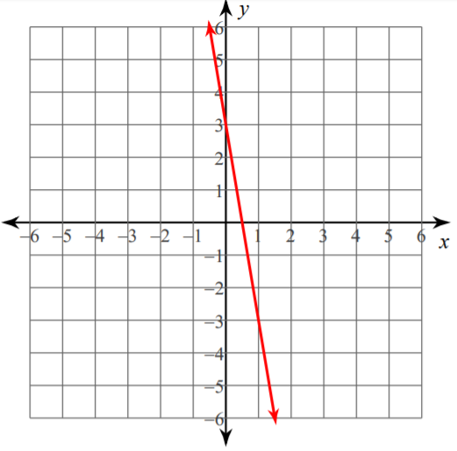  Slope: y-intercept: | 3.  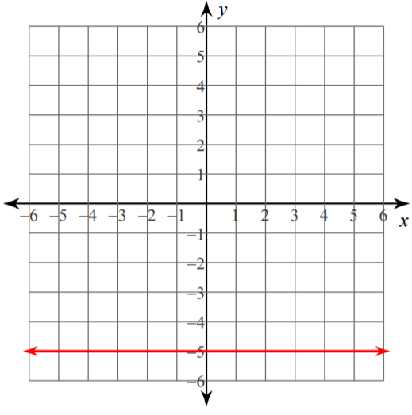  Slope: y-intercept:
4.  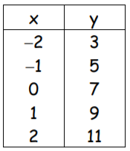  Slope: y-intercept: | 5.  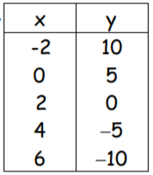  Slope: y-intercept: | 6.  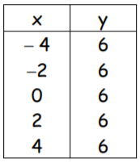  Slope: y-intercept:

