Name: ___________________ Table#: ______ Period: ______ Date: ______

**4.3A HW**

Tell whether *x* and *y* are in a proportional relationship. Explain your reasoning. If so, write an equation that represents the relationship.

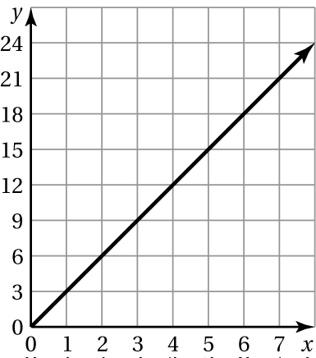

1. 2. 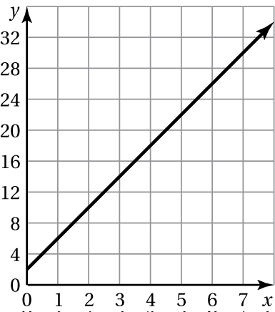

3. 4.

|  |  |  |  |  |
| --- | --- | --- | --- | --- |
| *x* | 4 | 8 | 12 | 16 |
| *y* | 1 | 2 | 3 | 4 |

|  |  |  |  |  |
| --- | --- | --- | --- | --- |
| *x* | 5 | 10 | 15 | 20 |
| *y* | 1 | 3 | 5 | 7 |

|  |  |  |  |  |  |  |  |  |  |  |  |  |  |  |  |  |  |  |  |  |  |  |  |  |  |  |  |  |  |  |  |
| --- | --- | --- | --- | --- | --- | --- | --- | --- | --- | --- | --- | --- | --- | --- | --- | --- | --- | --- | --- | --- | --- | --- | --- | --- | --- | --- | --- | --- | --- | --- | --- |
| 1. The store chares $4 for 5 gel pens.  |  |  |  |  |  |  |  |  | | --- | --- | --- | --- | --- | --- | --- | --- | | x | 0 | 1 | 2 | 3 | 4 |  | 5 | | y |  |  |  |  |  |  | $4 |   Interpret the slope: | 1. Three avocadoes cost $2.25.  |  |  |  |  |  |  |  | | --- | --- | --- | --- | --- | --- | --- | | x | 0 | 1 | 2 | 3 | 4 | 5 | | y |  |  |  | $2.25 |  |  |   Interpret the slope: |

BACK 🡪

7. The cost *y* (in dollars) to rent a lane at the bowling alley is proportional to the number *x* of hours that you rent the lane. It costs $18 to rent the lane for 2 hours.

a. Write an equation that represents the situation.

b. Interpret the slope.

c. How much does it cost to rent the lane for 3 hours?

8. The graph relates the height of the water   
in a tank *y* (in inches) to the 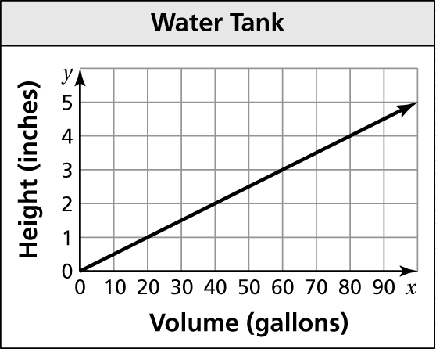volume of   
the water *x* (in gallons).

1. Is the relationship proportional? Explain.

b. Write an equation of the line. Interpret   
the slope.

c. What is the height of the water in the tank   
when the volume is 250 gallons?