Name: ________________________ Table #: _________ Period: ______ Date: ______
4.3B Graphing Proportional Relationships_Classwork

Objective: Graph proportional relationships, interpret the unit rate as the slope. Compare two different proportional relationships represented in different ways. (CCSS: 8.EE.5)
HW: (4.3B) p.162 #1, 3 – 6, 8 – 10 (solutions on p. A20)

WARM-UP: For the equations below, solve for y.
Example. 3x – 3y = 15  -3x -3x  -3y = -3x + 15  -3 -3 -3  y = x – 5  Slope: 1 y-intercept: -5 | 1. 2x – y = 5  Slope: y-intercept: | 2. -6x + 3y = - 12  Slope: y-intercept:

EXAMPLE 1: The weight y of an object on Titan, one of Saturn’s moons, is proportional to the weight x of the object on Earth. An object that weighs 105 pounds on Earth would weigh 15 pounds on Titan.

- Write an equation that represents the situation. | - How much would a spacecraft that weighs 3500 pounds on Earth, weigh on Titan?

EXAMPLE 2: The cost y (in dollars) to rent a luxury sports car is proportional to the number of days x that the car is rented. It costs $355 to rent the car for 5 days.

- Write an equation that represents the cost to rent a luxury sports car for x days. | - How much would it cost to rent the car for 1 week?

EXAMPLE 3: The daily wage y (in dollars) of a factory worker is proportional to the number of parts x assembled in a day. A worker who assembles 250 parts in a day earns $75.

- Write an equation that represents the situation? | - How much does a worker earn who assembles 300 parts in a day?

EXAMPLE 4: Watch the video for Example 3 (Section 4.3) then do #3
A maple tree grows 1.5 feet each year. The table shows the yearly growth for a pine tree.

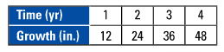

- Which tree grows faster?

- Graph maple and pine tree on the same graph.
- Write equations that represent the growth rates of each tree.
Maple tree equation: ____________________

Pine tree equation: ______________________

- Compare the steepness of the graphs. What does this mean in the context of the problem?
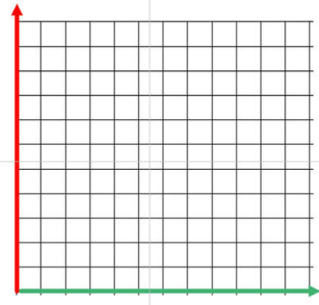

Name: _______________________________________ Table# ______ Per ____ Date ___________
4.3B HW p.162 #1, 3 – 6, 8 – 10 (solutions on p. A20)

1. ____________ 3. ________________________________ 4. ________________________________
________________________________ ________________________________
________________________________ ________________________________
________________________________ ________________________________

5. ________________________________ 6. ________________________________
________________________________ ________________________________
________________________________ ________________________________
________________________________ ________________________________

8a, 8b, 8c

9a & 9b.
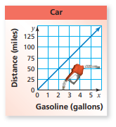

10a & 10b
Toenails: 13 millimeters per year (hint: write an equation or make a table) Fingernails: see table (p. 163)


   