Name: _________________________ Table #: _______ Period: ______ Date: ________
4.3C Solving Inequalities Using Multiplication and Division_Classwork

Objective: solve inequalities using multiplication or division; solve real-life problems. CC.SS.7.EE.4
ACTIVITY: Complete the table. Decide which graph represents the solution of the inequality.
EXAMPLE 1:
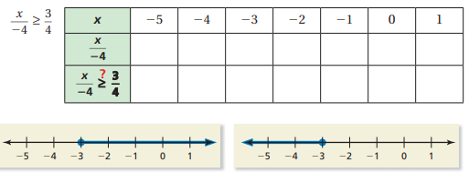

EXAMPLE 2:
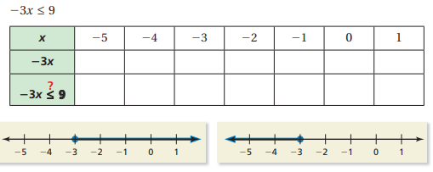

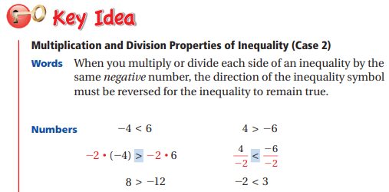
**NOTE** $-\frac{1}{2}=\frac{-1}{2}=\frac{1}{-2}$

YOU TRY!
- $-\frac{x}{3}>-4$ | - $0.5≤-\frac{y}{2}$ | - $-12≥-\frac{6}{5}m$ | - $-\frac{2}{5}h≤-8$

YOU TRY!
- $-5z<35$ | - $-2a>-9$ | - $-1.5<-3n$ | - $-4.2≥-0.7w$

CRITICAL THINKING. Are the solutions to the following inequalities the same? Explain why or why not.
$$2x<-12 and -2x<12$$

