Name: _________________________ Table #: ________ Period: ___________ Date: _____
4.4A Graphing Linear Equations in Slope Intercept Form_Classwork
Objective: Analyze graphs to determine slope, y-intercept and equation of the line. CCSS: 8.EE.6
HW: (4.4A) p. 170 #4 – 15 (Solutions on p. A22)

Graph each equation. Find the slope and the point where each line crosses the y-axis
(y-intercept) y = mx + b

- $y=-5+2x$  Slope: __________  y-intercept: __________  x y  0  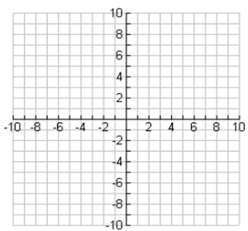 | - $y-5=-2x$  Slope: __________  y-intercept: __________  x y  0
- $x+2y=4$  Slope: __________  y-intercept: __________  x y  0 | - $y+7=\frac{x}{2}$  Slope: __________  y-intercept: __________  x y  0
4.4A Notes (Slope Intercept Form: y = mx + b)
*** Start with “Lesson Launch” on back ***
SLOPE INTERCEPT FORM
Y = m x + b

Identify the slope (m) and y-intercept (b) of each graph. Then write the equation of the line (y=mx+b)
1.  slope __________  y-intercept ______  equation ______________  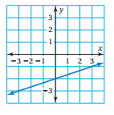 | 2.  slope __________  y-intercept ______  equation ______________  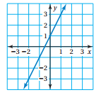 | 3.  slope __________  y-intercept ______  equation ______________  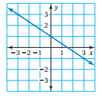
4.  slope __________  y-intercept ______  equation ______________  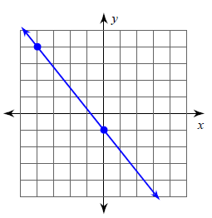 | 5.  slope __________  y-intercept ______  equation ______________  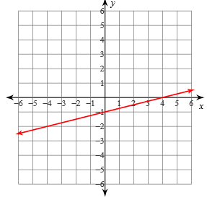 | 6. Write the equation of the line  whose graph has a slope of  -3 and y-intercept of 4.

DIRECTION: for each problem, rewrite it in slope-intercept form.
$$y=4-3x$$ | $$y-4=\frac{3}{4}x$$
$$2\left(x+y\right)=4$$ | $$2x+4y=8$$
$$4+4y=2x$$ | $$y=-4+5x$$
$$y+5=2x$$ | $$3\left(2x-y\right)=9$$

DIRECTION: for each problem, rewrite it in slope-intercept form.
$$y=4-3x$$ | $$y-4=\frac{3}{4}x$$
$$2\left(x+y\right)=4$$ | $$2x+4y=8$$
$$4+4y=2x$$ | $$y=-4+5x$$
$$y+5=2x$$ | $$3\left(2x-y\right)=9$$

Follow Up Questions to 4.4A Notes
- What do you notice about the slope of the line and its equation? Can you identify the slope of the line without graphing? Explain.
______________________________________________________________________________________________________________________________________________________________________________________________________________________________________________________
- What is the value of x at the y-intercept? ____________________________________________
- What do you notice between the point of intersection with the y-axis (y-intercept) and its equation? Can you identify the y-intercept of the line without graphing? Explain.
______________________________________________________________________________________________________________________________________________________________________________________________________________________________________________________
__________________________________________________________________________________________________________________________________________________________________

