Name: _________________________ Table #: ________ Period: ___________ Date: _____
4.4B Graphing Linear Equations in Slope Intercept Form_Classwork
Objective: Analyze graphs to determine slope, y-intercept, x-intercept and equation of the line. CCSS: 8.EE.6
HW: 4.4B worksheet
p. 168
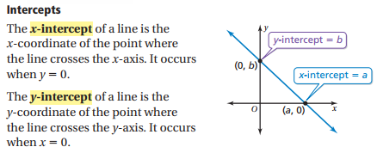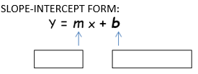

1a. Graph $y=x-4$. Identify the x-intercept. 1b. Graph $y= -\frac{1}{2}x+1$. Identify the x-intercept.
slope: _______ y-intercept: _______ slope: _______ y-intercept: _______
$\frac{rise}{run}= \frac{y}{x}$ $\frac{rise}{run}= \frac{y}{x}$
x-intercept: ______ x-intercept: ______

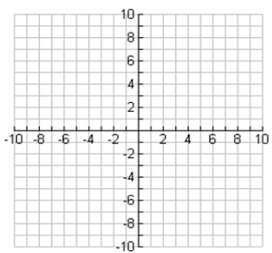

2a. Graph $y=-2x$. Identify the x-intercept. 2b. Graph $y= \frac{1}{3}x-2$. Identify the x-intercept.
slope: _______ y-intercept: _______ slope: _______ y-intercept: _______
$\frac{rise}{run}= \frac{y}{x}$ $\frac{rise}{run}= \frac{y}{x}$
x-intercept: ______ x-intercept: ______

For the equation -3x + 2y = -8

1. Solve for y | 2. Identify the slope and y-intercept  m = _______ (slope)  b = _______ (y-intercept)
3. Graph  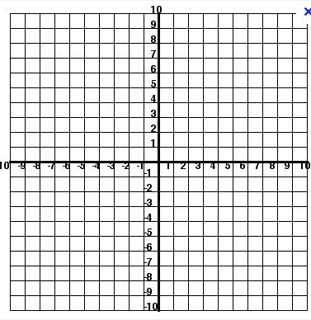 | 4. Identify 3 solutions of the equation  (pick 3 ordered pairs that lie on the  line)
5. Pick one of the points from #4 and prove algebraically that it is a solution
(HINT: Substitute the x-coordinate for “x” and the y-coordinate for “y” into the
equation)

