Name: _______________________Table #: _____Period: _____ Date ________ 4.4B Homework

For each equation:
- Identify the slope and y-intercept
- Graph

- Equation: $y=\frac{1}{4}x-1$  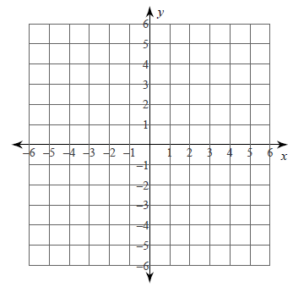  slope (m) =  _____________  y-intercept (b) =  _____________  x-intercept (a) =  ______________ | - Equation: $y=-3x-3$  slope (m) =  _____________  y-intercept (b) =  _____________  x-intercept (a) =  ______________  slope (m) =  _____________  y-intercept (b) =  _____________
- Equation: $y=-x+2$  slope (m) =  _____________  y-intercept (b) =  _____________  x-intercept (a) =  ______________ | - Equation: $y=\frac{4}{3}x-4$  slope (m) =  _____________  y-intercept (b) =  _____________  x-intercept (a) =  ______________
- Equation: $y=4x+3$  slope (m) =  _____________  y-intercept (b) =  _____________ | - Equation: $y=-\frac{1}{2}x+3$  slope (m) =  _____________  y-intercept (b) =  _____________  x-intercept (a) =  ______________

BACK
For each equation:
- Solve for y
- Identify the slope and y-intercept
- Graph

- Equation: $2x+y=2$  slope (m) =  _____________  y-intercept (b) =  _____________  x-intercept (a) =  ______________ | - Equation: $4x+5y=20$  slope (m) =  _____________  y-intercept (b) =  _____________  x-intercept (a) =  ______________
- Equation: $2x-y=-4$  slope (m) =  _____________  y-intercept (b) =  _____________  x-intercept (a) =  ______________ | - Equation: $x-2y=8$  slope (m) =  _____________  y-intercept (b) =  _____________  x-intercept (a) =  ______________

