Name: __________________ Table #: _____ Period: ______ Date: _____
4.5A Graphing Using Intercepts_Classwork
Objective: graph linear equations written in standard form. Applying Standard 8.EE.6
HW: 4.5A HW (handout)
Ax + By = C (A, B, C are fixed integer values) – this form is called STANDARD FORM
1. You sold a total of $16 worth of tickets to a school concert. You lost track of how many of each type
you sold. Let x represent the number of adult tickets. Let y represent the number of student
tickets. Adult tickets cost $4 and student tickets cost $2. Write an equation that relates x and y.

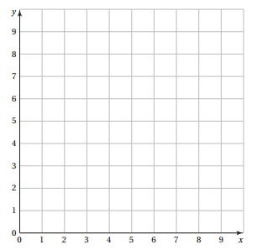

2. Make a graph using the two points  (7, 0) and (0, -3)  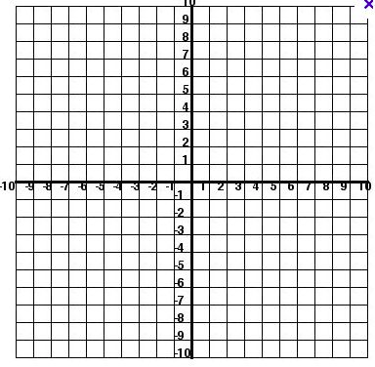 | 3. Make a graph using the two points:  (-4, 0) and (0, 5)
Record the ordered pairs for the x- and y-intercepts of the graphs below.
4. x-intercept = _________  y-intercept = _________  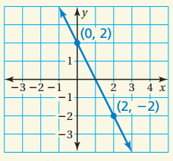 | 5. x-intercept = _________  y-intercept = _________  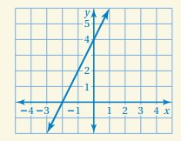
What do you notice about the coordinates of the x-intercepts? __________
What do you notice about the coordinates of the y-intercepts? __________
- y =mx + b use the slope and y-intercept in order to graph the linear function
- Ax + By = C use the x-intercept and y-intercept in order to graph the linear function
EXAMPLE: Graph using intercepts
2x + 3y = 12
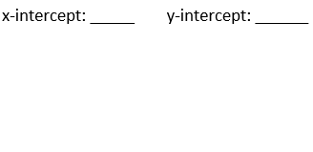

Graph using intercepts
6. –x + 3y = 6
7. 8x – 2y = 16
---------------------------------------------------------------------------------------------------------------------------------------
*******WARM UP************
- Is (-2, 6) a solution to the graph of the linear equation 3x + 2y = 6? | - Is (3, -1) a solution to the graph of the linear equation 3x + 2y = 6?

