Name: __________________________________ Table# ____ Per ___ Date _______
4.5A Homework – Equations in Standard Form: X- and Y-Intercepts
Find the x- & y-intercepts of each equation
1.  $$x+2y=18$$  x-intercept: _____ y-intercept: ______ | 2.  $$3x-y=9$$  x-intercept: _____ y-intercept: ______
$$-2x-3y=-12$$  x-intercept: _____ y-intercept: ______ | 4.  $$-8x+4y=40$$  x-intercept: _____ y-intercept: ______
Continued on back
Find the x- and y-intercepts. Then graph the linear equations using the intercepts.
5.  $$x+y=2$$  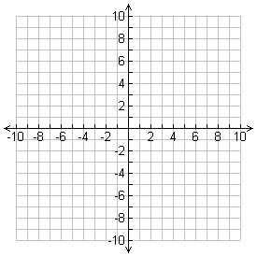  x-intercept: _____ y-intercept: _____ | 6.  $$5x-3y=15$$  x-intercept: _____ y-intercept: _____
7.  $$4y=3x+12$$  x-intercept: _____ y-intercept: _____ | 8.  $$2x+y=-8$$  x-intercept: _____ y-intercept: _____
Solutions: 1. (18, 0), (0, 9) 2. (3, 0), (0, -9) 3. (6, 0), (0, 4) 4. (-5, 0), (0, 10) 5. (2, 0), (0, 2) 6. (3, 0), (0, -5)
7. (-4, 0), (0, 3) 8. (-4, 0), (0, -8)

