Name: __________________ Table #: _____ Period: ______ Date: _____
4.5B Graphing Using Intercepts_Classwork
Objective: graph linear equations written in standard form. Applying Standard 8.EE.6
HW: 4.5B HW (handout)

Use your 4.5A Notes for assistance
1. Find the x- & y-intercepts  -2x + 3y = -6  x-intercept: _______ y-intercept: ________ | 2. Find the x- & y-intercepts  8x – 7y = 16  x-intercept: _______ y-intercept: ________
3. Find the x- & y-intercepts  4x + 8y = 16  x-intercept: _______ y-intercept: ________ | 4. Find the x- & y-intercepts  5x + 6y = 13  x-intercept: _______ y-intercept: ________
5. Find the x- & y-intercepts  -3x – 6y = 18  x-intercept: _______ y-intercept: ________ | 6. Find the x- & y-intercepts  -7x + 3y = 10  x-intercept: _______ y-intercept: ________
Summary: Using details and examples, describe what a linear equation in standard form (Ax + By = C) looks like to get integers when you calculate the x- and y-intercepts.

7. SOLVE FOR Y AND WRITE THE EQUATION IN SLOPE-INTERCEPT FORM. THEN IDENTIFY THE SLOPE AND
Y-INTERCEPT: -5X + 3Y = -9

DIRECTIONS: For the following equations:
1) If it is in slope-intercept form, then identify the slope and y-intercept.
2) If it is in standard form, then identify the x- & y-intercept.
3) Would you graph using slope and intercept OR using the x-& y-intercepts? Explain your reasoning.
7) y = 2x - 3

8) 4x + 5y = 20

9) 6x – y = 13

Name: _____________________________  Quizlet (4.5C) – Exit Slip  Graph the linear equation 2x + 3y = 6  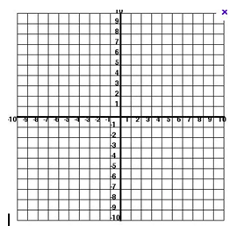 | Name: _____________________________  Quizlet (4.5C) – Exit Slip  Graph the linear equation 2x + 3y = 6
Name: _____________________________  Quizlet (4.5C) – Exit Slip  Graph the linear equation 2x + 3y = 6 | Name: _____________________________  Quizlet (4.5C) – Exit Slip  Graph the linear equation 2x + 3y = 6

