Name: ___________________ Table #: ______ Period: ______ Date: _____
4.6B HW

Use the equation in standard form,if the problem is given a total value.
Use the equation in slope-intercept form, $y=mx+b$ if the problem is given an initial value and a constant rate of change (slope). Neither variable (x and y) is dependent on the other.

- You have $0.80 in your backpack in dimes and quarters. Let x represent the number of dimes and y represent the number of quarters.

- Write an equation in standard form that represents the situation.

- If you have 2 quarters in your backpack, how many dimes do you have?

- A baby weighs 14 pounds at 5 months and 21 pounds at 10 months.

- Write an equation in slope-intercept form that relates the baby’s weight, y, to the baby’s age, x.

- Use your equation to find how much the baby weighed at birth.

- How many pounds did the baby gain each month after in its first year?

- Gabriel earns $8 per hour working for his uncle. Fill in the table, make a graph and describe
how the unit rate is represented on the graph. Include the x- & y-axis labels.
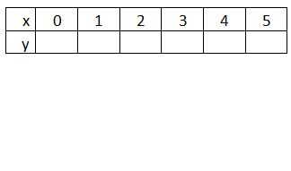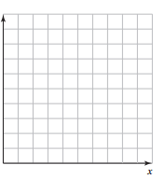
Write your equation in SLOPE-INTERCEPT FORM:

INTERPRETATION OF SLOPE
(Describe how the unit rate is represented on the graph):

For each ‘real-life’ problem below:
- Write an equation in slope intercept form (y = mx + b) that represents the situation
- Interpret the slope and the y-intercept (write a sentence for each one).
- A rental car charges $29 to rent a car plus $45 per day. | - Mario’s pizza charges $7 for a medium pizza plus $0.75 per additional topping.
- A long distance company charges a $2.50 connection fee, plus $0.10 a minute. | - A tow truck charges $25 to pick you up plus $7 per mile for the tow.

