Name: ____________________ Table #: __________ Period: _______ Date: ______
4.7A Point-Slope Form_Classwork
Objective: write equations of lines using a slope and a point; write equations of lines using two points. CC.SS.8.F.4
HW: 4.7A worksheet

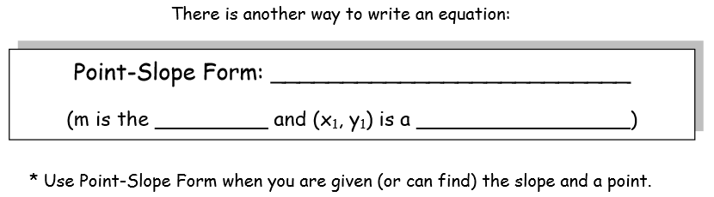
Graph each of the following lines by first giving the point and the slope.
1. $y+2=\frac{1}{3}(x+1)$  Point ___________ Slope ___________  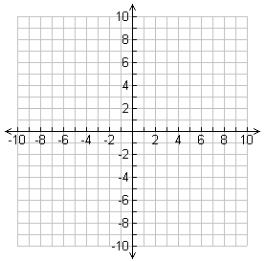 | 2. $y+1=-\frac{1}{2}(x-3)$  Point ___________ Slope ___________
3. $y-3=-2(x-4)$  Point ___________ Slope ___________ | 4. $y-5=3x$  Point ___________ Slope ___________
- Write an equation in point-slope form of the line that passes through the point (1, 2) and has a slope of 4.

- Write an equation in point-slope form of the line that passes through the point (-7, 3) and has m = ½.

- Write an equation in point-slope form of the line that passes through the point (-2, -5) and (0, -3).

- Write an equation in point-slope form  Step 1: Identify one point on line: _____  Step 2: Calculate slope: _____________  Step 3: Write equation: _____________  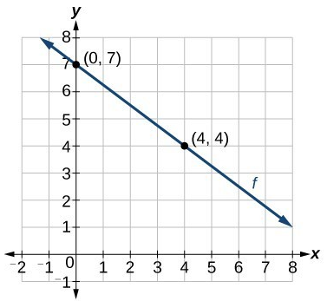 | - Write an equation in point-slope form  Step 1: Identify one point on line: _____  Step 2: Calculate slope: _____________  Step 3: Write equation: _____________  