Name: _________________________ Table #: _______ Period: ______ Date: ______
Chapter 8 SBAC Volumes_Classwork
Warm Up:
1. Solve for r:  $16πr^{2}=64π$ |  | 2. Solve  $\frac{4}{5}x=8$ | 3. Solve  $\frac{4}{5}x= \frac{24}{15}$
Shapes | *** When finding volume,$use π=$3.14 ***
Cylinder  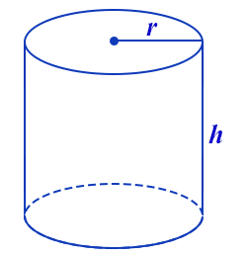  $$V=π∙r^{2}∙h$$ | p. 338 #12: A cylindrical swimming pool has a diameter of 16 feet and a height of 4 feet. About how many gallons of water can the pool contain? Round your answer to the nearest whole number. ($1{ ft}^{3}≈7.5 gal)$
Cone  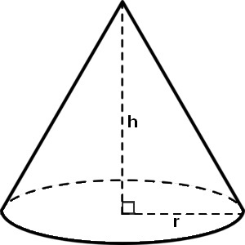$$V=(π∙r^{2}∙h) ÷3$$  or  $$V=\frac{π∙r^{2}∙h }{3}$$ | p. 345 #20 a: You have 10 gallons of lemonade to sell (($1gal≈{ 3785 cm}^{3})$. Each customer uses one paper cup. How many paper cups will you need if the paper cup is 6 cm in diameter and 11 cm in height?
Sphere  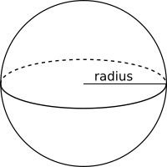  $$V=(4∙π∙r^{3}) ÷3$$  or  $$V=\frac{4∙π∙r^{3} }{3}$$ | p. 352 #13 modified: A giant softball has a volume of $\frac{1000}{6}π$ cubic inches. Find the radius of the softball.
Hemisphere  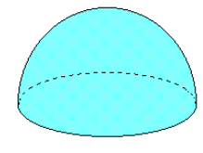  $V=\frac{4∙π∙r^{3} }{3}$ $÷2$  or  $$V=\frac{4∙π∙r^{3} }{6}$$ | p. 352 #12 modified: The globe of the Moon has a radius of 10 inches. Find the volume of the hemisphere. Round your answer to the nearest whole number.
Pyramid  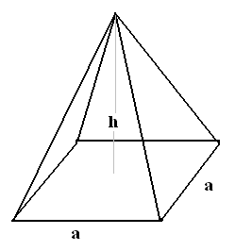  $$V=(a∙a)h ÷3$$  or  $$V=\frac{a∙a∙h }{3}$$ | p. 365 #13: Find the volume of the composite solid.  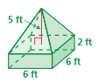
Determine whether the solids are similar.
16. A similar scale model of the motorcylce shown stands 4 inches high and is 6 inches long. How high does the actual motorcycle stand? Round to the nearest tenths if necessary.
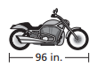

HW: Chapter 6 Review, p. 279 #1 – 15 (do in BIM)

