Name: ___________________________________ Table #: _______ Period: _____ Date: _____
5.0A Complex Fractions_Classwork
Objective: find ratios, rates, and unit rates involving ratios of fractions. CC.SS.7.RP.1 and RP.3
HW: 5.0A worksheet

REVIEW
- Convert the measurement:  - 30 min = _______ hr  - 4 hr = __________min  - 15 sec = _______ min  - 60 hr = ________ days  - 3 days = _______ hr  - 1 wk = ________ hr | - Are the fractions equivalent? Explain.  $$\frac{12}{48} and\frac{9}{18}$$ | - Solve the equation.  $$\frac{1}{7}n=-4$$
- Solve the equation  $$-2w=-9$$ | - Solve the equation  $$6=2w$$ | - Solve the equation.  $$\frac{y}{-5}=3$$

REVIEW: $\frac{3}{8}÷\frac{1}{2}=$

Simplifying expressions that contain fractions.
Show how you can rewrite each expression as division problem. Then simplify.
- $\frac{\frac{1}{2} cup}{4 fl oz}$ | - $\frac{\frac{5}{6}gal}{\frac{2}{3} sec}$

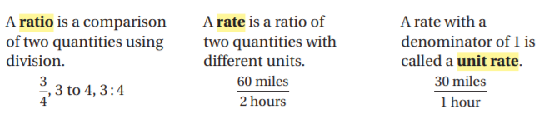

CRITICAL THINKING PROBLEM:
A communications satellite in orbit travels about 18 miles every 4 seconds. You can use the ratio table below to find and organize equivalent ratios and rates. Complete the ratio table below.
- How far does the satellite travel in 1 second?

- How can you use a ratio table to find the speed of the satellite in miles per minute?

- How can you use a ratio table to find the speed of the satellite in miles per hour?

- How far does the satellite travel in ½ second?

