Name ___________________ Table #: _____ Period: _____ Date: ______
5.1A Solving Systems of Linear Equations by Graphing_Classwork

Objective: write and solve systems of linear equations by graphing. CC.SS.8.EE.8a/b/c
HW: textbook – 5.1A pg 206 #8-16 ALL

Special Case Equations When Graphing:
EXAMPLE 1: $Graph$  $$x=3 and y=-4$$  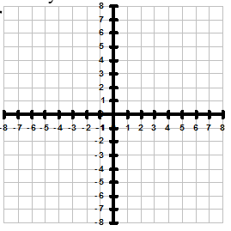  Solution: _________________ | EXAMPLE 2: $Graph$  $$x+3y=12 and y=5$$  Solution: _________________
EXAMPLE 3: $Graph$  $$10x-4y=0 and y=6-\frac{1}{2}x$$  Solution: _________________ | EXAMPLE 4: $Graph$  $$y=\frac{1}{2}x-4 and 4x-8y=48$$  Solution: _________________
When doing business, you have COSTS (how much it costs for you to run your business) and REVENUE (money you collect from your customers). When your costs equal your revenues, you BREAK EVEN. You have made zero dollars in profit, but your costs are covered. Break Even equation is C = R or R = C.
EXAMPLE 5:
The cost c (in dollars) for fuel and maintenance of a moped rental company is given by the equation c = 60x + 1200, where x is the number of days to rent the moped. It costs $80 per day.
- Write an equation for the revenue R in terms of the number of days. _______________________

- How many days does it take to break even?

PRACTICE PROBLEMS
- $Graph$  $$-x+y=-3 and y=1-\frac{1}{3}x$$  Solution: ___________ | - $Graph$  $$-x+2y=-4 and y=\frac{1}{2}x+2$$  Solution: ___________
- The cost c (in dollars) to run a company that provides skydiving is given by the equation c = 60x + 6000, where x is the number of jumps from the airplane. It costs $100 per jump.

- Write an equation for the revenue R in terms of the number of jumps. _______________________

- How many jumps does it take to break even?

WARM-UP (REVIEW FROM CHAPTER 4)
- Graph y = 5 | - Graph x = -2 | - Write 3x + 2y = 8 in slope-intercept form (y = mx + b)  - Write y = -6x - 1 in standard form (Ax + By = C)

