Name: ___________________ Table #: ________ Period: ______ Date:_____
5.1B Unit Rates_Classwork
Objective: find ratios and rates involving ratios of fractions. CC.SS.7.RP.1 and CC.SS.7.RP.3
HW: 5.1B worksheet

WARM-UP
Write the ratio as a fraction in simplest form.
- 25 feet to 45 feet | - 35 girls : 15 boys

- 150 miles in 3 hours | - $5.50 for 5 pounds

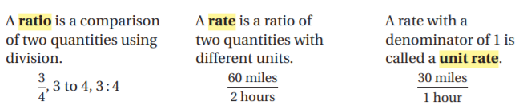

Find the Unit Rate
1.  180 miles in 3 hours | 2.  256 miles per 8 gallons | 3.  $9.60 for 4 pounds
4.  $74.75 for a 5 gal gloss white paint | 5.  $1.19 for a 12 oz grape juice | 6.  $2.35 for a dozen egg

BACK
7.  Use the ratio table to find the unit rate with the specified units.  Servings per package  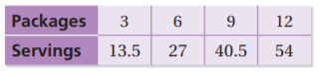 | 8.  Use the ratio table to find the unit rate with the specified units.  Feet per year  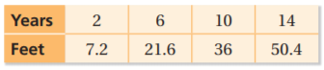
9.
A Sports store sells three different packs of tennis balls. Which pack is the best buy? Explain.
